Name

Mathematics Stage 4
Equations

Book 1 | Solve linear equations up to 2 steps | Version: 260706  Feedback:  https://MrDingMaths.com
Contents
Syllabus Content 2
Learning Intention Error! Bookmark not defined.

Syllabus Content
MA4-EQU-C-01 solves linear equations of up to 2 steps and quadratic equations of the form $ax^{2}=c$
Solve linear equations up to 2 steps
- Represent number sentences involving unknown quantities using pronumerals
- Describe number sentences as equations
- Distinguish between and compare algebraic expressions and equations
- Solve linear equations with integer and non-integer solutions using algebraic techniques that involve up to 2 steps, including equations with pronumerals on both sides
- Model and solve word problems using equations of up to 2 steps
Solve and verify linear equations by substitution
- Verify solutions to equations by substitution

Algebraic Equations and Solutions

- Review
- Work with equality
Determine whether these statements are true or false.
$$8+2=7+3$$ | $$14-3=13-4$$ | $$4\left(2\right)=10-2$$ | $$3\left(9\right)=30-3$$

- Operate with integers
- $-3+5$ | - $-3-5$ | - $3-5$ | - $3+5$
- $3+\left(-5\right)$ | - $3-\left(-5\right)$ | - $5-\left(-3\right)$ | - $-5+\left(-3\right)$

- Substitute and evaluate expressions
- $x+5$ when $x=2$ | - $5x$ when $x=3$
- $3-2x$ when $x=1$ | - $-3x+1$ when $x=-2$

- Equations
An equation has an equals symbol (=) with expressions on both sides.
Equations have a Left-Hand Side (LHS) with the same value as the Right-Hand Side (RHS).

$$5+3=4+4$$
LHS RHS
Algebraic Expression  $$2x+x+6$$  No equals sign.  $x$ represents any number.  You simplify expressions. | Algebraic Equation  $$2x+x=6$$  Equals sign relates two expressions.  $x$ represents a fixed value.  You solve equations.

- Identify Equations
✖  $$3x+5$$ | ✔  $$3x+5=11$$ |  | ✔  $$y=7$$ |  | ✔  $$5a-8=2a+1$$ |  | ✖  $$4x+1=$$
Identify which of the following are equations
- $5x$ |  | - $x=9$ |  | - $2+3=5$ |  | - $4=3+1$
- $x+3=3+x$ |  | - $8=$ |  | - $0=2x+1$ |  | - $y+5$

- Key Ideas
- An equation is a mathematical statement with an …………… sign.
- An equation must have an expression on …………… sides of the equals sign.
- The expression to the left of the equals is called the ………, and RHS is the expression to the …………… of the equals sign.
- The equals symbol means that the two sides have the same …………………

- Solutions
A solution of an equation is the value of the pronumeral that makes the equation true.
An equation is true when the left-hand side (LHS) is the same as the right-hand side (RHS)
We say that a solution satisfies the relationship shown in the equation.

- Interpret Solutions of an equation
A solution is a value that makes the equation true.
For $x+3=7$, the solution is $x=4$ because $4+3=7$
We say that $x=4$ satisfies the equation.

A solution is a value that makes the equation …………………
A value that makes the equation true is called a …………………
We say that a solution ……………… the equation.

For $3+x=9$, the solution is $x=$ ……… because …………………

For $12=x+10$, the solution is $x=$ ……… because …………………

For $2x=10$, we can say that $x=5$ ………………… the equation.

- Key Ideas
- A solution of an equation is a value that makes the equation …………………………
- An equation is true when ……… … ………
- We say that a solution ………………… the relationship shown in an equation.

- Verifying Solutions
Verify means to check if something is true.
To verify solutions:
- Substitute the value into the LHS and evaluate.
- Substitute the value into the RHS and evaluate.
- Compare: If LHS = RHS, it is a solution. If LHS ≠ RHS, it is not a solution.

- Example Verify solutions to algebraic equations
Verify whether $x=5$ is a solution of $2x+5=3x$
1. $LHS = 2\left(5\right)+5=15$  2. $RHS = 3\left(5\right)=15$  3. $LHS=RHS$  $x=5$ is a solution | Verify means to ……………… if something is true.  A given pronumeral is a solution if ……… $=$ ……… after ………………… it into the equation.
Verify whether $x=4$ is a solution of $2+3x=15$
1. $LHS = 2+3\left(4\right)=14$  2. $RHS = 15$  3. $LHS≠RHS$  $x=4$ is not a solution | In this example, we did not need to calculate the RHS because ………………………………………………………  If LHS is not the same as RHS, then the given pronumeral is not a ……………………

- Guided Practice
- Verify whether $x=2$ is a solution of $4x+1=9$ | - Verify whether $x=3$ is a solution of $5x-4=10$
- Verify whether $x=6$ is a solution of $15=3x$ | - Verify whether $x=$ $\frac{3}{2}$ is a solution of  $$2x=\frac{9}{2}-x$$

- Key Ideas
- To verify a solution, we ……………… the value into both sides and compare LHS and RHS

Foundation

- Verify whether $x=3$ is a solution of  $$x+1=4$$ | - Verify whether $x=4$ is a solution of  $$12-3x=4-x$$
yes | yes
- Verify whether $b=4$ is a solution of  $$12-3b=5-b$$  no | - Verify whether $x=0.5$ is a solution of  $$\frac{4x}{6}=\frac{1}{3}$$  yes
- Verify whether $x=5$ is a solution of  $$15+2x=x^{2}$$ | - Verify whether $x=3$ is a solution of  $$7x+2=8x$$
yes | no
- Verify whether $x=-1$ is a solution of  $$x\left(x+1\right)=0$$ | - Verify whether $x=-3$ is a solution of  $$3x+3=3(x+1)$$
yes | yes
- Verify whether $x=7.5$ is a solution of  $$\frac{2x}{5}+5=10$$  no | - Verify whether $x=-2$ is a solution of  $$x^{2}+4x+4=0$$  yes

Solving Equations by Inspection

- Review
- Fluency in addition and multiplication facts
- $6+$ …… $=10$ | - $3=12-$ …… |  | - $3$(……) $=12$ |  | - $\frac{15}{……}=3$
- $2($……) $+3=11$ |  | - $20=8+4($……) |  | - $\frac{……}{5}$ $+3=7$

- Verify whether the given pronumeral is a solution
- Is $x=3$ a solution of $x+5=8$? | - Is $x=7$ a solution of $3x+1=29$?

- Solving an Equation
A solution is the value of the pronumeral that makes the equation true.
Solving an equation means to find the solution.
We can solve simple equations by inspection – noticing the answer.

- Example Solve equations by inspection
Solve $3x=12$  $x=4$ | Solve $20-2x=10$  $x=5$

- Guided Practice
Solve these equations by inspection.
- $x+5=9$ | - $x-2=6$
- $4x=20$ | - $2x+3=4$
- $10x+3=43$ | - $\frac{x}{3}$ $=6$

- Key Ideas
- Solving an equation means finding the value of the pronumeral that makes the equation ………………
- We can check, or verify, our solution by ……………… the value back into the equation.

Foundation
- Find the solution to these equations.
3 | 10 | 6 | 20
6 | 4 | 70 | - same number in both  19

- Solve these equations by inspection. Pay attention to how each question changes.
- $3+x=8$  5 | - $7=x-6$  13 | - $7+x=0$  – 7
- $x+3=8$  5 | - $-7=x-6$  – 1 | - $-7+x=0$  7
- $8=x+3$  5 | - $-7=-6+x$  – 1 | - $-7+x=$ $\frac{1}{2}$  7.5
- $8=x-3$  11 | - $-7+x=-6$  1 | - $x-7=$ $\frac{1}{2}$  7.5
- $9=x-3$  12 | - $-7+x=-7$  0 | - $x+7=$ $\frac{1}{2}$  – 6.5
- $9=x-4$  13 | - $7+x=-7$  – 14

- Solve these equations by inspection. Pay attention to how each question changes.
- $3x=18$  6 | - $5=$ $\frac{x}{3}$  15 | - $-15=-3x$  5
- $3x=15$  5 | - $-5=$ $\frac{x}{3}$  – 15 | - $-16=2x$  – 8
- $3x=5$  $$\frac{5}{3}$$ | - $-5=-$ $\frac{x}{3}$  15 | - $-16=4x$  – 4
- $\frac{x}{3}$ $=5$  15 | - $-15=-$ $\frac{x}{3}$  45 | - $-16=16x$  – 1

Development
- Solve these equations by inspection. Pay attention to how each question changes.
- $2x+3=21$  9 | - $2x+23=21$  – 1
- $3+2x=21$  9 | - $\frac{x}{2}$ $+3=21$  36
- $2x-3=21$  12 | - $3x+3=21$  6
- $3-2x=21$  – 9 | - $6x+3=21$  3
- $2x+4=21$  8.5 | - $\frac{x}{4}$ $+3=21$  72
- Solve these equations by inspection. Pay attention to how each question changes.
- $x+5=11$  6 | - $10+4x=22$  3
- $2x+7=13$  3 | - $100+4x=220$  30
- $2x+10=16$  3 | - $4x+100=110$  2.5
- $3x+10=19$  3 | - $2x+100=110$  5
- $4x+10=22$  3 | - $20x+100=110$  0.5

- Find the solution to these equations.
- $2(x-1)=4+2$  4 | - $2=17-x-1$  14
- $\frac{x}{2}$ $=$ $\frac{60}{4}$  120 | - $12×5=2(x+3)$  27

Mastery
- Find two possible values of $t$ that make the equation $t(10-t)=21$ true.
3 or 7
- List possible solutions to $y=x+10$
Is there a limit to the number of solutions?

$x=1, y=11 \left| x=2, y=12 \right| x=-42.39, y=-32.39$. No limit.
- Explain why the equation $x+3=x$ has no solutions.

It is not possible to add 3 to a number and have the number be unchanged.

Equivalent Equations

- Review
- Combine like terms by addition/subtraction
- $2x+3+5$ | - $2x+3-5$ | - $2x+3-3$
- $3-2x+3$ | - $5+6x-3$ | - $-2x-3+4x$

- Expand brackets
- $2\left(3x+1\right)$ | - $3\left(7x+2\right)$ | - $\frac{6x+3}{3}$

- Investigate Equivalent equations
Solve for the value of $x$ in these equations.
- $x+1=4$ $x=$ …………
$+5 +5$
- $x+6=9$ $x=$ …………
$-3 -3$
- $x+3=6$ $x=$ …………
$×2 ×2$
- $2x+6=12$ $x=$ …………
$×3 ×3$
- $6x+18=36$ $x=$ …………
$÷2 ÷2$

What do you notice about your answers?

All of these equations are equivalent.
Equivalent equations have the same ……………………
If we do the same ……………… to both sides, we create an equivalent equation.

- Equivalent Equations
Equivalent equations have the same solution.
If we apply the same operation to both sides of an equation, we get an equivalent equation.
Unbalanced  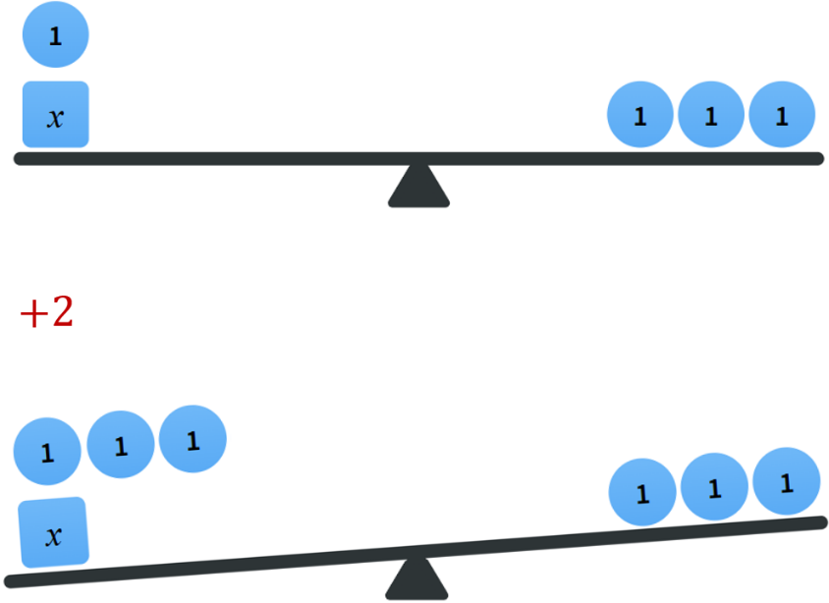 | Balanced  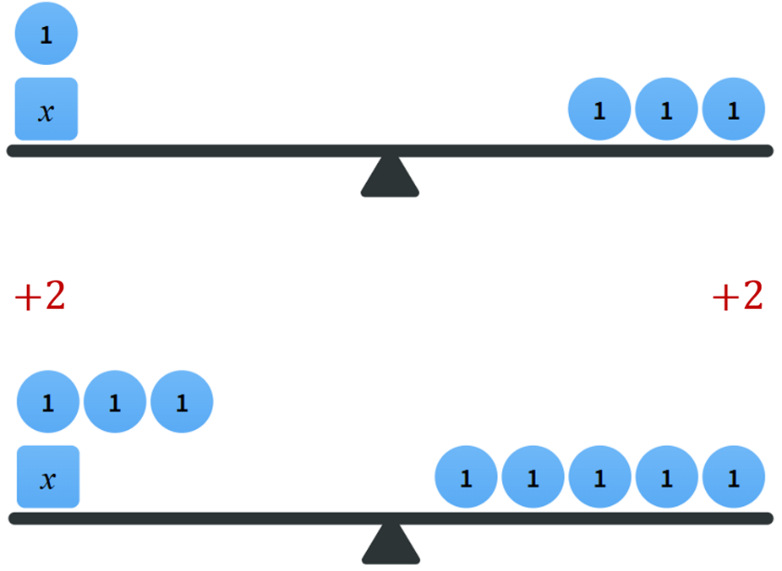
When working with equations, line up the equal symbols and write a new line for each operation you do.

- Example Produce equivalent equations by addition/subtraction
$$3x+2=8 \\ -2=-2 \\ 3x=6$$ | $$2x=5 \\ +4=+4 \\ 2x+4=9$$

- Guided Practice
Write the equivalent equation after the operation.
$$x+5=12$$  $$-5 -5$$  …… $=$ …… | $$2x=14$$  $$+3 +3$$  …… $=$ ……
$$3x+2=-4$$  $$-2 -2$$  …… $=$ …… | $$\frac{x}{2}-5=1$$  $$+5 +5$$  …… $=$ ……
$$3+2x=11$$  $$-3 -3$$  …… $=$ …… | $$7=2+5x$$  $$+2x +2x$$  …… $=$ ……

- Equivalent Equations: Multiplying
When multiplying or dividing both sides, we must multiply or divide every term.
Unbalanced  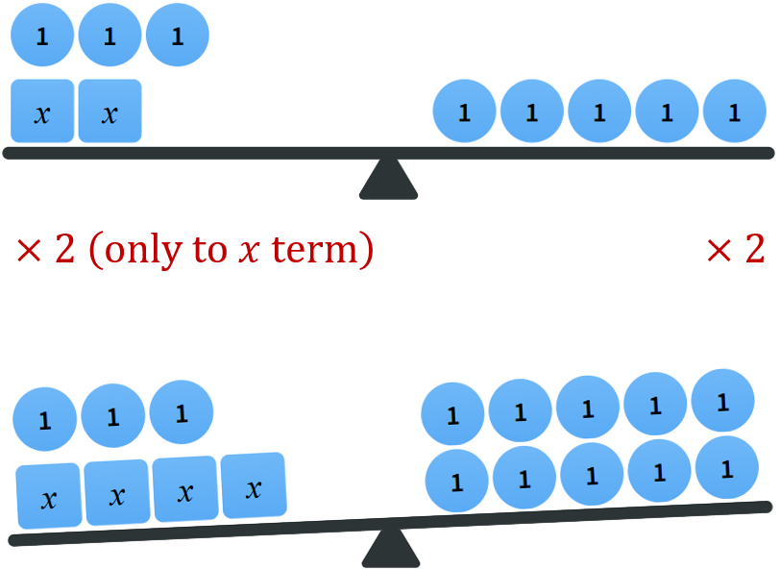 | Balanced  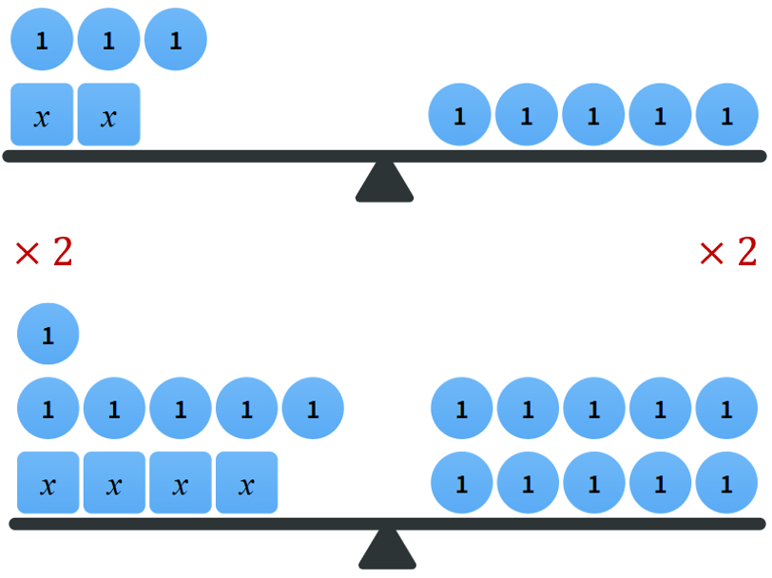

- Example Produce equivalent equations by multiplication/division
$$2x+5=8 \\ ×3=×3 \\ 6x+15=24$$ | $$6x+4=10 \\ ÷2=÷2 \\ 3x+2=5$$

- Guided Practice
Write the equivalent equation after the operation.
- $2x=9$  $×4 ×4$ | - $x+3=6$  $×2 ×2$ | - $2x-3=4$  $×5 ×5$
- $6x+9=12$  $$÷3 ÷3$$ | - $2x-4=3$  $÷2 ÷2$ | - $25=5+15x$  $$÷5 ÷5$$

- Key Ideas
- Equations with the same solution are called ……………… equations.
- To make equivalent equations, apply the same ……………… to …………… sides of an equation.
- When adding or subtracting, we simplify by combining …………… terms.
- When multiplying or dividing, we must apply the operation to every ……………

Foundation
- For each equation, show the equivalent equation after the operation shown is applied to both sides.
- $10d+5=20$  $+10 +10$  ………… $=$ …………  $$10d+15=30$$ | - $7e=31$  $+3 +3$  ………… $=$ …………  $$7e+3=34$$ | - $5+x=10$  $+1 +1$  ………… $=$ …………  $$6+x=11$$
- $3x=7$  $×2 ×2$  ………… $=$ …………  $$6x=14$$ | - $12=8q$  $÷4 ÷4$  ………… $=$ …………  $$3=2q$$ | - $9+a=13$  $-3 -3$  ………… $=$ …………  $$6+a=10$$
- $7+b=10$  $+5 +5$  ………… $=$ …………  $$12+b=15$$ | - $5=3b+7$  $-5 -5$  ………… $=$ …………  $$0=3b+2$$ | - $12x-3=3$  $+5 +5$  ………… $=$ …………  $$12x+2=8$$

- Determine the operation done to both sides.
$x+2=4$  …… ……  $x=2$  $$-2$$ | $2x+4=6$  …… ……  $2x=2$  $$-4$$
$4x+2=6$  …… ……  $2x+1=3$  $$÷2$$ | $3x=6$  …… ……  $x=2$  $$÷3$$
$a+7=9$  …… ……  $a=2$  $$-7$$ | $3a=21$  …… ……  $a=7$  $$÷3$$
$3x+6=18$  …… ……  $3x=12$  $$-6$$ | $\frac{x}{3}$ $=12$  …… ……  $x=36$  $$× 3$$

Development
- Draw lines to match up the equation on the top with the equivalent equation on the bottom, where 3 has been added to both sides.
- $10+x=14$  $+3 +3$ | - $x+1=13$  $+3 +3$ | - $12=x+5$  $+3 +3$ | - $x+10=11x$  $$+3 +3$$

A $x+13=11x+3$ | B $13+x=17$ | C $x+4=16$ | D $15=x+8$

a – B, b – C, c – D, d – A
- These equations are equivalent. Determine the operation that has been done to both sides.
- $4x+2=10$  ………… …………  $4x=8$  – 2 | - $7+3b=12$  ………… …………  $9+3b=14$  $$+ 2$$ | - $20a=10$  ………… …………  $2a=1$  $$÷ 10$$
- $4=12-x$  ………… …………  $8=24-2x$  × 2 | - $18=3x$  ………… …………  $$6=x$$  $$÷ 3$$ | - $12+x=3$  ………… …………  $15+x=6$  $$+ 3$$
- $40+4b=80$  ………… …………  $10+b=20$  ÷ 4 | - $12x=5$  ………… …………  $12x+4=9$  $$+ 4$$ | - $2x+3=5$  ………… …………  $x+\frac{3}{2}=\frac{5}{2}$  $$÷ 2$$

- Write down the missing expressions using the operation shown between each line.
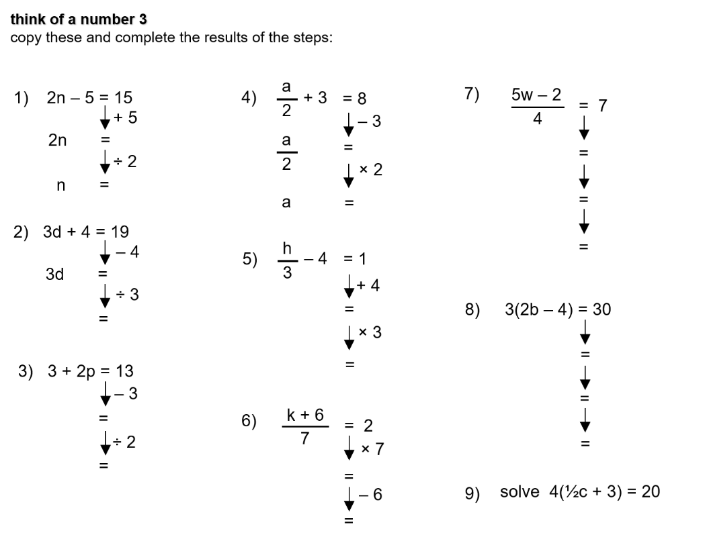  $$2n=20$$  $$n=10$$ | $$3d=15$$  $$d=5$$ | $$2p=10$$  $$p=5$$
$$\frac{a}{2}=5$$  $$a=10$$ | $$\frac{h}{3}=5$$  $$h=15$$ | $$k+6=14$$  $$k=8$$

- Write down the operations done between each line of working out.
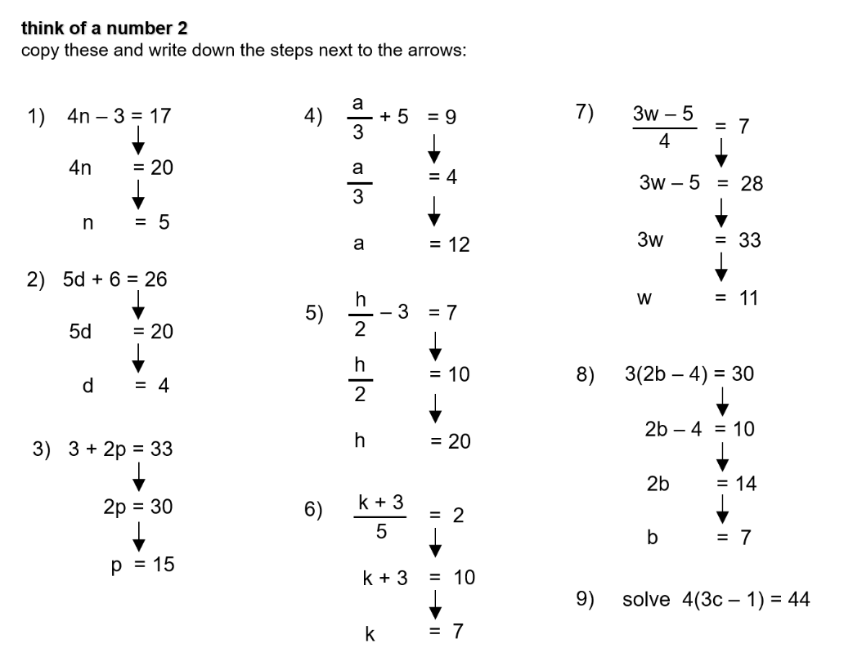  + 3  ÷ 4 | – 6  ÷ 5 | – 3  ÷ 2
– 5  × 3 | +3  × 2 | × 5  – 3
× 4  + 5  ÷ 3 | ÷ 3  +4  ÷ 2

- For each equation, show the equivalent expression after adding 4 to both sides then multiplying both sides by 3.
- $x=5$  ………… $=$ …………  $$x+4=9$$  ………… $=$ …………  $$3x+12=27$$ | - $2=a+1$  ………… $=$ …………  $$6=a+5$$  ………… $=$ …………  $$18=3a+15$$ | - $d-4=2$  ………… $=$ …………  $$d=6$$  ………… $=$ …………  $$3d=18$$
- $7+a=8$  ………… $=$ …………  $$11+a=12$$  ………… $=$ …………  $$33+3a=36$$ | - $3y-2=7$  ………… $=$ …………  $$3y+2=11$$  ………… $=$ …………  $$9y+6=33$$ | - $2x=6$  ………… $=$ …………  $$2x+4=10$$  ………… $=$ …………  $$6x+12=30$$

- Complete the loop by carrying out the operation shown to both sides of the equation.
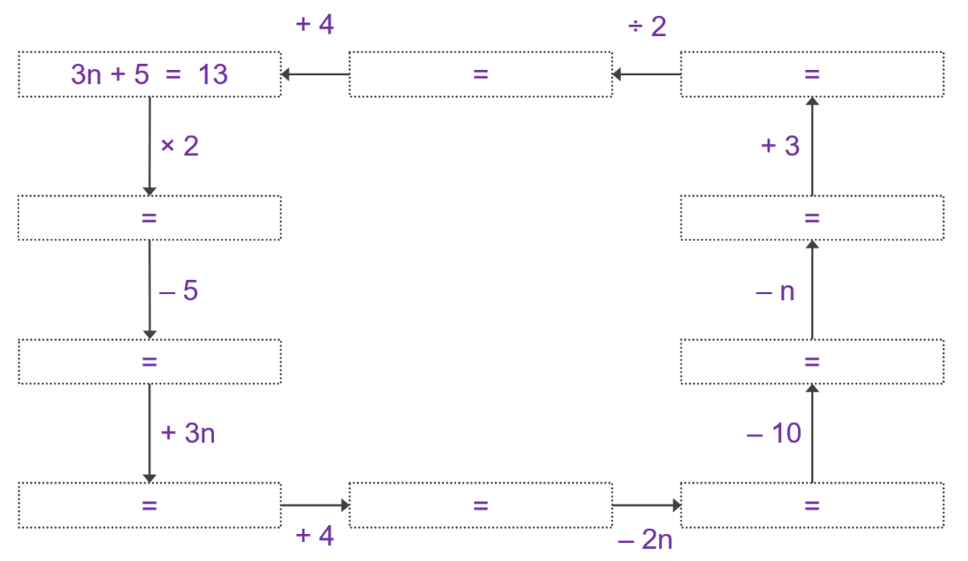

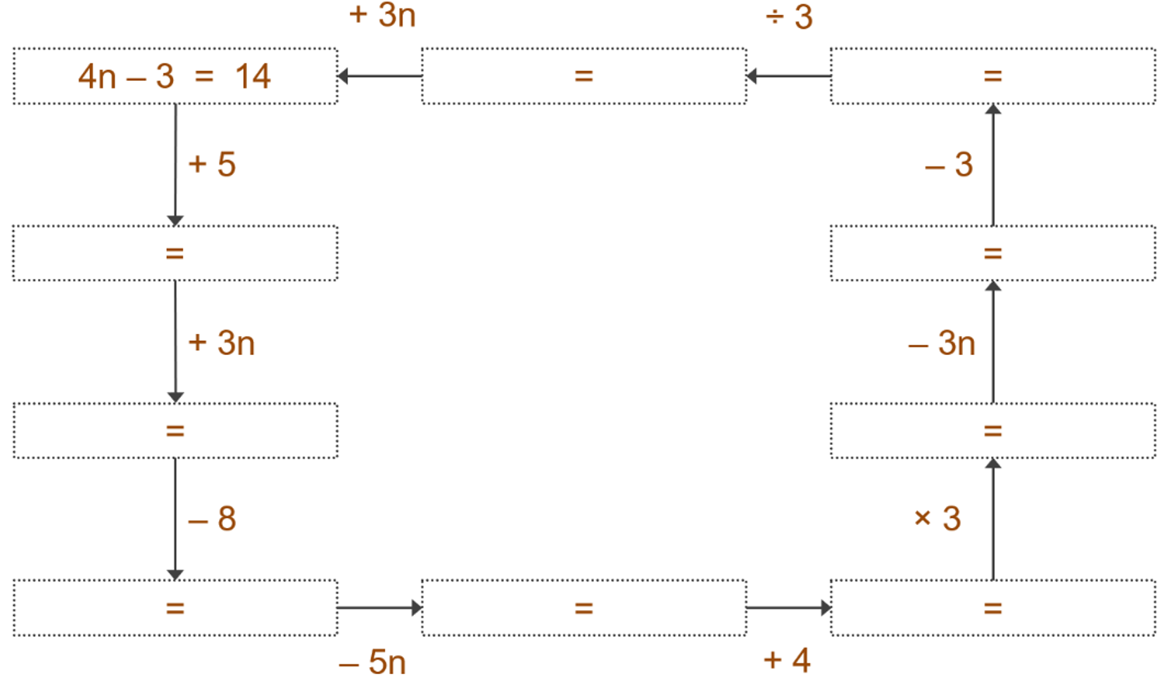

- For each equivalent equation, indicate the operation that has been done to both sides.
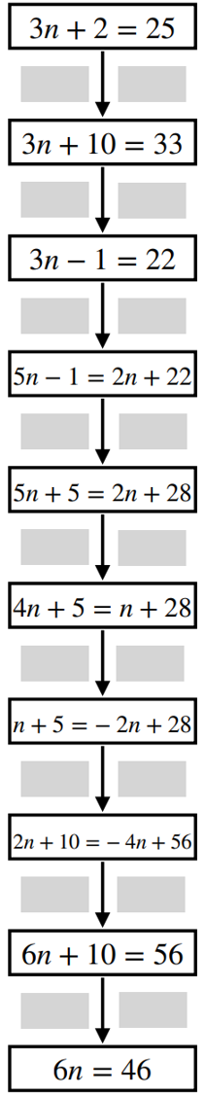  + 8  – 11  + 2n  + 6  – n  – 3n  × 2  + 4n  – 10 | 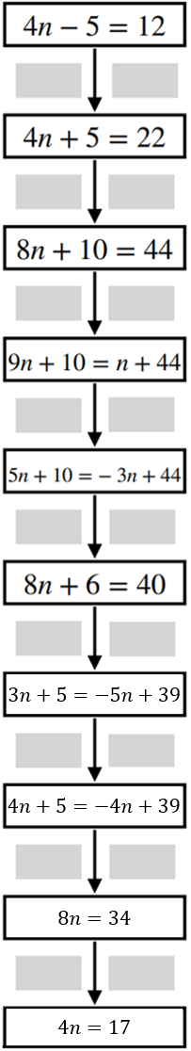  + 10  × 2  + n  – 4n  + 3n – 4  – 5n – 1  + n  + 4n – 5  ÷ 2

Mastery

- Complete to show $3x+2=14$ is equivalent to $10x+1=41$  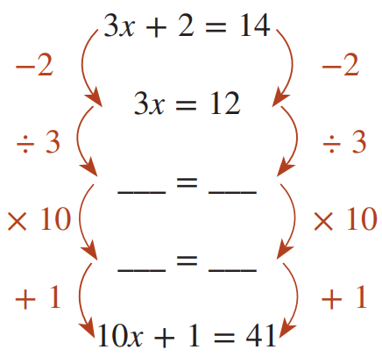  $$x=4$$  $$10x=40$$ | - Do something similar to show that  $5x-3=32$ is equivalent to $x+2=9$  (hint: find the value of $x$ first)

- Given that $\frac{p}{9}=39$, write down the value of these expressions.
$$40$$ | 351 | 88 | 1053

- Use your knowledge of equivalence to find the value of an expression given the value of another expression.
- $3n^{2}+2n=15$  19  – 4  60 | - $2.5d-3=8$  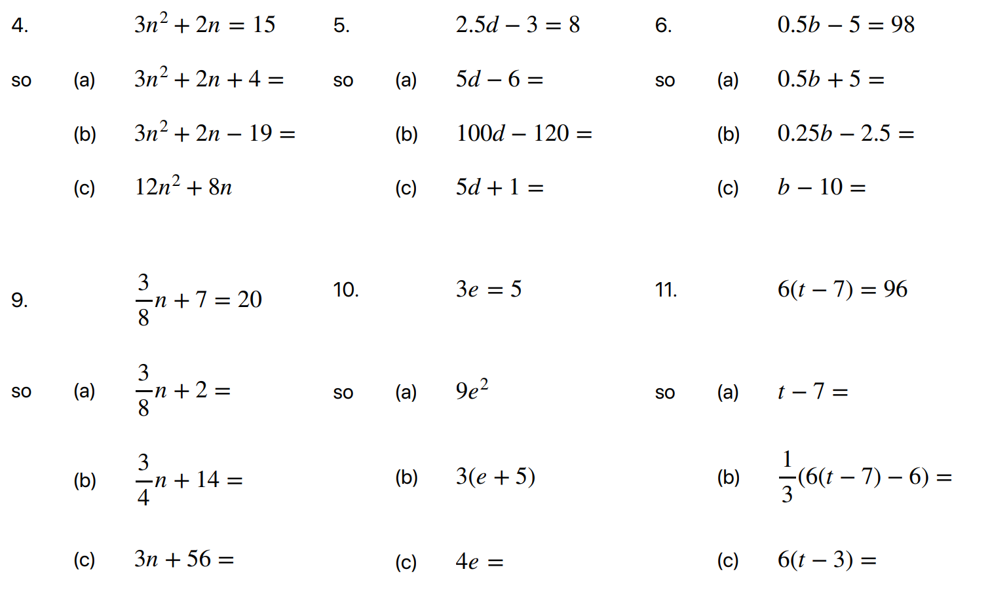  16  320  23
- $0.5b-5=98$  108  49  196 | - $3e=5$  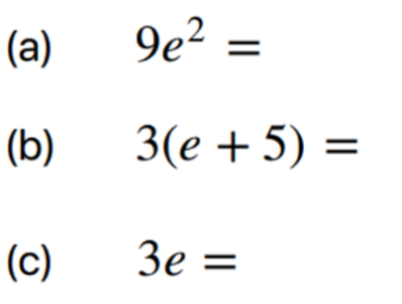  25  20  5
- $\frac{3}{8}$ $n+7=20$  15  30  120 | - $6\left(t-7\right)=96$  16  30  120

Inverse Operations

- Review
- Identify operation done to $x$
$$x\underset{→}{ +2 }x+2$$ | $$x\underset{→}{ }x+8$$ | $$x\underset{→}{ }x-7$$ | $$x\underset{→}{ }3x$$
$$x\underset{→}{ }\frac{x}{4}$$ | $$x\underset{→}{ }x+11$$ | $$x\underset{→}{ }9x$$ | $$x\underset{→}{ }x-9$$
$$x\underset{→}{ }\frac{x}{5}$$ | $$x\underset{→}{ }-6x$$ | $$x\underset{→}{ }x+3$$ | $$x\underset{→}{ }-\frac{x}{2}$$
$$x\underset{→}{ }7x$$ | $$x\underset{→}{ }x+7$$ | $$x\underset{→}{ }7+x$$ | $$x\underset{→}{ }x-7$$
$$x\underset{→}{ }\frac{x}{7}$$ | $$x\underset{→}{ }-7x$$ | $$x\underset{→}{ }-\frac{x}{7}$$ | $$x\underset{→}{ }\frac{1}{7}x$$

- Inverse Operations
Inverse operations undo each other.
Addition and subtraction are inverses.
Multiplication and division are inverses.

- Identify Inverse Operation
$$x+4\underset{→}{ -4 }x$$ | $$4x\underset{→}{ ÷4 }x$$ | $$-4x\underset{→}{ ÷\left(-4\right) }x$$
Identify the inverse operation
$$x+3\underset{→}{ }x$$ | $$x-3\underset{→}{ }x$$ | $$\frac{x}{3}\underset{→}{ }x$$
$$3x\underset{→}{ }x$$ | $$3+x\underset{→}{ }x$$ | $$-3x\underset{→}{ }x$$
$$-\frac{x}{3}\underset{→}{ }x$$ | $$x-11\underset{→}{ }x$$ | $$14x\underset{→}{ }x$$

Foundation
- Identify the inverse operation.
$$x-2\underset{→}{ }x$$  $$+2$$ | $$5x\underset{→}{ }x$$  $$÷5$$ | $$\frac{x}{4}\underset{→}{ }x$$  $$×4$$
$$12x\underset{→}{ }x$$  $$÷12$$ | $$x+6\underset{→}{ }x$$  $$-6$$ | $$x-17\underset{→}{ }x$$  $$+17$$
$$\frac{x}{6}\underset{→}{ }x$$  $$×6$$ | $$11x\underset{→}{ }x$$  $$÷11$$ | $$2x\underset{→}{ }x$$  $$÷2$$
$$x+89\underset{→}{ }x$$  $$-89$$ | $$-10x\underset{→}{ }x$$  $$÷\left(-10\right)$$ | $$x+\frac{1}{2}\underset{→}{ }x$$  $$-\frac{1}{2}$$
$$5.5x\underset{→}{ }x$$  $$÷5.5$$ | $$-\frac{x}{3}\underset{→}{ }x$$  $$×\left(-3\right)$$ | $$x-0.02\underset{→}{ }x$$  $$+0.02$$
$$x-9\underset{→}{ }x$$  $$+9$$ | $$65+x\underset{→}{ }x$$  $$-65$$ | $$0.6x\underset{→}{ }x$$  $$÷0.6$$

- Identify the inverse operation.
$$x-5\underset{→}{ }x$$  $$+5$$ | $$x+5\underset{→}{ }x$$  $$-5$$ | $$5+x\underset{→}{ }x$$  $$-5$$
$$5x\underset{→}{ }x$$  $$÷5$$ | $$-5x\underset{→}{ }x$$  $$÷\left(-5\right)$$ | $$-\frac{x}{5}\underset{→}{ }x$$  $$×(-5)$$
$$\frac{x}{5}\underset{→}{ }x$$  $$×5$$ | $$\frac{1}{5}x\underset{→}{ }x$$  $$×5$$ | $$-5+x\underset{→}{ }x$$  $$+5$$

One-Step Equations

- Review
- Solve equations by inspection
- $x+3=5$ | - $x-11=10$ | - $x+5=3$ | - $3x=18$

- Create equivalent equations
- $x+7=12$  $-7 -7$ | - $x-12=5$  $+12 +12$ | - $5x=20$  $$÷5 ÷5$$
- $\frac{x}{3}$ $=5$  $×3 ×3$ | - $5+x=17$  $-5 -5$ | - $6=$ $\frac{x}{3}$  $$×3 ×3$$

- Identify operations done to $x$
$x\underset{→}{ }x+8$ | $x\underset{→}{ }3x$ | $x\underset{→}{ }-2x$
$$x\underset{→}{ }\frac{x}{6}$$ | $x\underset{→}{ }2+x$ | $$x\underset{→}{ }\frac{x}{2}$$
$x\underset{→}{ }x-5$ | $x\underset{→}{ }7x$ | $$x\underset{→}{ }\frac{x}{15}$$

- Identify inverse operation
$$x+4\underset{→}{ }x$$ | $$x-5\underset{→}{ }x$$ | $$3x\underset{→}{ }x$$
$$\frac{x}{5}\underset{→}{ }x$$ | $$6x\underset{→}{ }x$$ | $$5+x\underset{→}{ }x$$
$$\frac{x}{10}\underset{→}{ }x$$ | $$-\frac{x}{10}\underset{→}{ }x$$ | $$-x\underset{→}{ }x$$

- Solving One-Step Equations
To solve equations, we isolate $x$ by applying inverse operations.
            - Identify the operation done to $x$.
            - Undo the operation done to $x$ by applying the inverse operation to both sides.
- One-step refers to how many inverse operations are needed to isolate $x$.

- Example Solve one-step equations
$x+7=12$  $-7 -7$  $x=5$ | $x$ had ……… done to it.  To isolate $x,$ we apply the …………… operation, which is $-7$.  We can check our solution by ……………… it back into the equation.

- Guided Practice
$$x+3=9$$  …… ……  $x$ $=$ …… | $$x-5=8$$  …… ……  $x$ $=$ ……
$$3x=12$$ | $\frac{x}{2}$ $=4$

- Key Ideas
- To solve an equation, we isolate $x$ using ………………… operations.
- The inverse of $+5$ is …………, the inverse of $-5$ is …………
- The inverse of $÷5$ is …………, the inverse of $×5$ is …………
- We apply the inverse operation to ……………… sides of the equation.

Foundation
- Solve these equations.
$$x+7=15$$  …… ……  $x=$ ………  $$8$$ | $$x-3=8$$  …… ……  $x=$ ………  $$11$$
$$3x=15$$  …… ……  $x=$ ………  $$5$$ | $$\frac{x}{3}=5$$  …… ……  $x=$ ………  $$15$$
$$x-9=6$$  …… ……  $x=$ ………  15 | $$5+x=12$$  …… ……  $x=$ ………  $$7$$
$$\frac{x}{2}=6$$  …… ……  $x=$ ………  $$12$$ | $$16=2x$$  …… ……  $x=$ ………  $$8$$
$$20=5x$$  …… ……  $x=$ ………  $$4$$ | $$5=7+x$$  …… ……  $x=$ ………  $$-2$$
$$-2x=6$$  …… ……  $x=$ ………  $$-3$$ | $$-\frac{x}{2}=-4$$  …… ……  $x=$ ………  $$8$$

- State the inverse operation to apply to both sides and the solution.
- $x+3=8$ $-3$ $x=$ …………  5  - $3+x=8$ ……… $x=$ …………  – 3 5  - $8=x+3$ ……… $x=$ …………  – 3 5  - $8=x-3$ ……… $x=$ …………  +3 11  - $9=x-3$ ……… $x=$ …………  +3 12  - $9=x-4$ ……… $x=$ …………  +4 13  - $7=x-6$ ……… $x=$ …………  +6 13  - $-7=x-6$ ……… $x=$ …………  +6 – 1  - $-7=-6+x$ ……… $x=$ …………  +6 – 1 | - $-7+x=-6$ ……… $x=$ …………  +7 1  - $-7+x=-7$ ……… $x=$ …………  +7 0  - $7+x=-7$ ……… $x=$ …………  – 7 – 14  - $7+x=0$ ……… $x=$ …………  – 7 – 7  - $-7+x=0$ ……… $x=$ …………  +7 7  - $-7+x=\frac{1}{2}$ ……… $x=$ …………  +7 7.5  - $x-7=\frac{1}{2}$ ……… $x=$ …………  +7 7.5  - $x+7=\frac{1}{2}$ ……… $x=$ …………  – 7 – 6.5

- State the inverse operation to apply to both sides and the solution.
- $3x=18$ $÷3$ $x=$ …………  6  - $3x=15$ ……… $x=$ …………  ÷ 3 5  - $3x=5$ ……… $x=$ …………  ÷ 3 $\frac{5}{3}$  - $\frac{x}{3}=5$ ……… $x=$ …………  × 3 15  - $5=\frac{x}{3}$ ……… $x=$ …………  × 3 15  - $-5=\frac{x}{3}$ ……… $x=$ …………  × 3 – 15  - $-5=-\frac{x}{3}$ ……… $x=$ …………  × (– 3) 15 | - $-15=-\frac{x}{3}$ ……… $x=$ …………  × (– 3) 45  - $-15=-3x$ ……… $x=$ …………  ÷ (– 3) 5  - $-16=2x$ ……… $x=$ …………  ÷ 2 – 8  - $-16=4x$ ……… $x=$ …………  ÷ 4 – 4  - $-16=8x$ ……… $x=$ …………  ÷ 8 – 2  - $-16=16x$ ……… $x=$ …………  ÷ 16 – 1

Development
- Show the inverse operations and solve these equations.
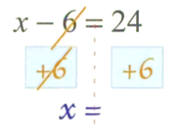  $$x = 30$$ | 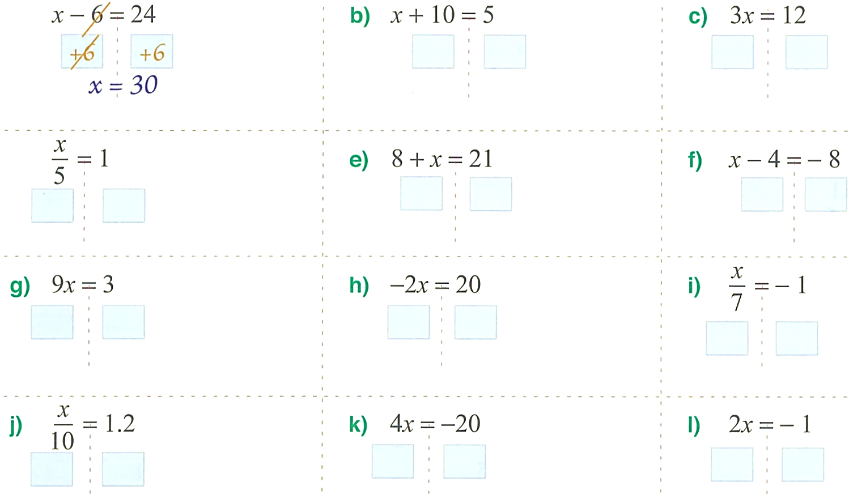  $$x = - 5$$ | $$x = 4$$
$$x = 5$$ | $$x = 13$$ | $$x = - 4$$
$$x = \frac{1}{3}$$ | $$x = - 10$$ | $$x = - 7$$
$$x = 12$$ | $$x = - 5$$ | $$x = - 0.5$$
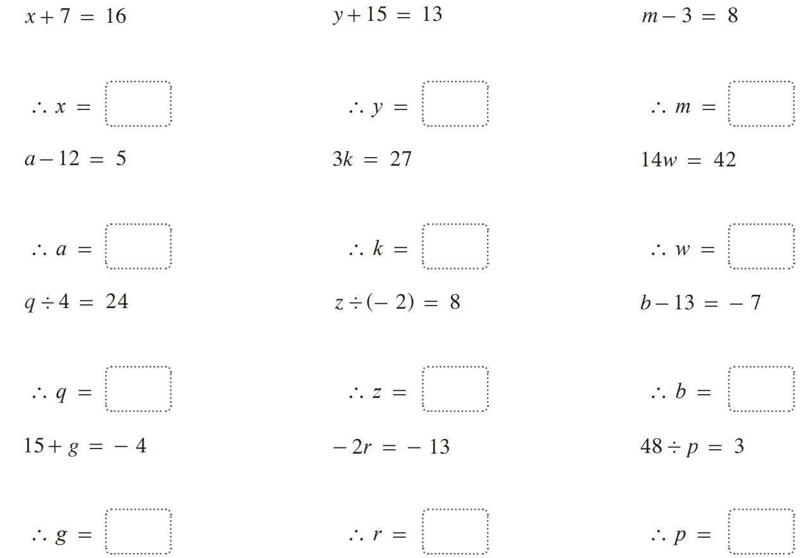  $$x = 9$$ | $$y = - 2$$ | $$m = 11$$
$$a = 17$$ | $$k = 9$$ | $$w = 3$$
$$q = 96$$ | $$z = - 16$$ | $$b = 6$$
$$g = - 19$$ | $$r = 6.5$$

- Solve these equations.
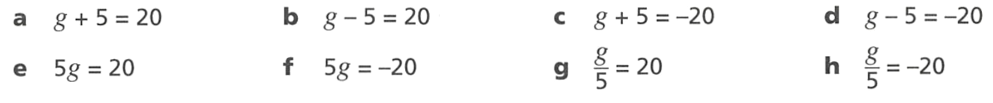  $$g = 15$$ | $$g = 25$$ | $$g = - 25$$ | $$g = - 15$$
$$g = 4$$ | $$g = - 4$$ | $$g = 100$$ | $$g = - 100$$

- Read the examples carefully and answer the questions.
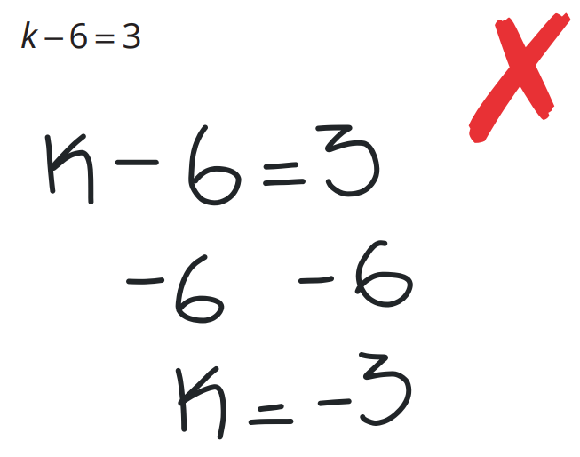  Marvin’s work: | Why is Marvin’s work incorrect?  He subtracted 6 from both sides instead of adding 6  How could Marvin have checked whether $-3$ was the correct answer?  By substituting it back into the equation  Solve:  $$k-52=39$$  91
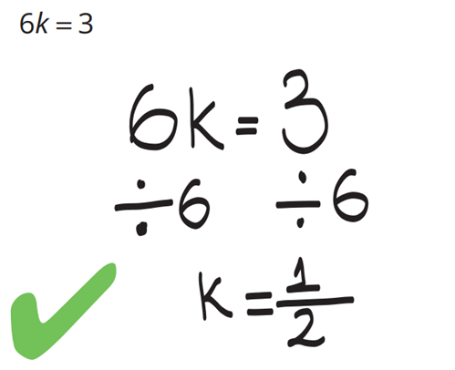  Hannah’s work: | Why couldn’t Hannah subtract 6 to get the k by itself?  k was multiplied by 6,  so the inverse operation is to divide, not subtract.  Solve:  $$\frac{k}{6}=3$$  18

Mastery
- Write an equation to represent the scenario, then solve to find the number.
  - A number is tripled to obtain the result 21.
$$3x=21$$
$$x=7$$
  - Six less than a number is 7.
$$x-6=7$$
$$x=13$$
  - A number is doubled and the result is −16.
$$2x=-16$$
$$x=-8$$
  - One-quarter of a number is 30.
$$\frac{x}{4}=30$$
$$x=120$$
  - Six more than a number is −7.
$$x+6=-7$$
$$x=-13$$
- Solve these equations
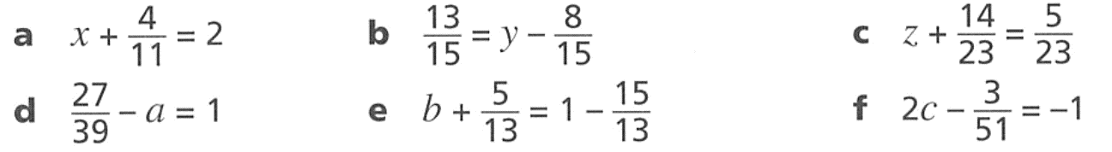  $$x=\frac{18}{11}$$ | $$y=\frac{7}{5}$$ | $$z=-\frac{9}{23}$$

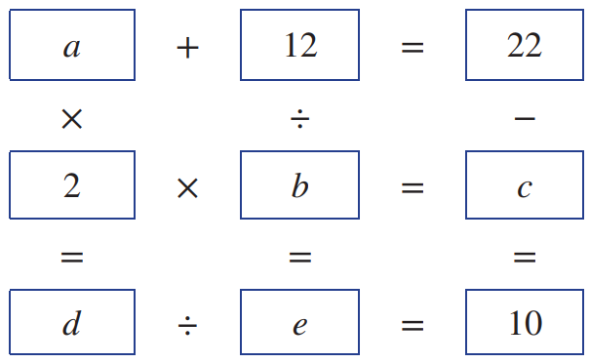
- There are six equations in the square below.
Find the values of the pronumerals to make all equations true.
$a=$ ……
$b=$ ……
$c=$ ……
$d=$ ……
$e=$ ……
$$a=10, b=6,c=12,d=20,e=2$$

- Solve these one-step equations involving negative integers.
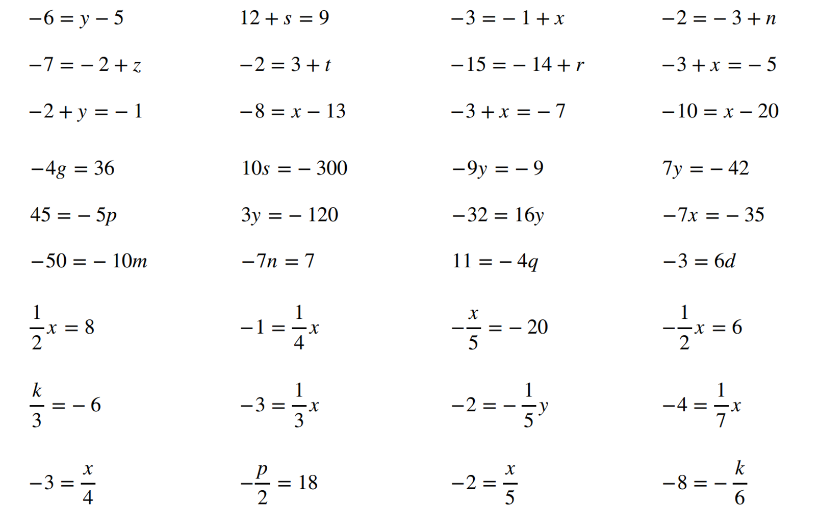  $$y=-1$$ | $$s=-3$$ | $$x=-2$$ | $$n=1$$
$$z=-5$$ | $$t=-5$$ | $$r=-1$$ | $$x=-2$$
$$y=1$$ | $$x=5$$ | $$x=-4$$ | $$x=10$$
$$g=-9$$ | $$s=-30$$ | $$y=1$$ | $$y=-6$$
$$p=-9$$ | $$y=-40$$ | $$y=-2$$ | $$x=5$$
$$m=5$$ | $$n=-1$$ | $$q=-\frac{11}{4}$$ | $$d=-\frac{1}{2}$$
$$x=16$$ | $$x=-4$$ | $$x=100$$ | $$x=-12$$
$$k=-18$$ | $$x=-9$$ | $$y=10$$ | $$x=-28$$
$$x=-12$$ | $$p=-36$$ | $$x=-10$$ | $$k=48$$

Two-Step Equations

- Review
- Evaluate according to order of operations
- $3×5+4$ | - $3+5×4$ | - $\frac{6}{3}$ $+5$
- $5+$ $\frac{6}{3}$ | - $2×7-6$ | - $5+4×3$

- Identifying Operations done to $x$
To undo operations and isolate $x,$ we need to identify what has happened to $x$ and in what order. Operations done to $x$ follow the order of operations.
Brackets
Indices
Division/Multiplication
Addition/Subtraction

- Identify operations done to $x$
$$2+3x$$  $$×3,+2$$ | $$\frac{x}{2}-3$$  $$÷2, -3$$ | $$2x-3$$  $$×2,-3$$
Identify the operations done to $x$ in the correct order.
- $3x+5$ | - $5+3x$ | - $4x-3$
- $-3+4x$ | - $\frac{x}{2}$ $-6$ | - $1+$ $\frac{x}{5}$

- Key Ideas
- In expressions like $3x+5,$ operations done to $x$ follow a specific ………………
- Multiplication and ………………… happen before ………………… and ……………………

- Identifying Order of Inverse Operations to Isolate $x$
To solve equations, we undo operations on $x$ in the opposite order of BIDMAS.
Order of operations done to $x$: Order of inverse operations to isolate $x$:
Brackets
Indices
Division/Multiplication
Addition/Subtraction
- Undo addition/subtraction done to $x$.
- Undo multiplication/division done to $x$.

- Identify order of inverse operations to isolate $x$
$$3x-2\underset{→}{ +2 }3x\underset{→}{ ÷3 }x$$ |  | $$2+\frac{x}{3}\underset{→}{ -2 }\frac{x}{3}\underset{→}{ ×3 }x$$
Identify the operations required to isolate $x$.
$$6x+2\underset{→}{ } 6x\underset{→}{ }x$$ |  | $$\frac{x}{5}-8\underset{→}{ } \frac{x}{5}\underset{→}{ }x$$
$$2+6x\underset{→}{ } \underset{→}{ }x$$ |  | $$2+\frac{x}{3}\underset{→}{ } \underset{→}{ }x$$
$$3x+2\underset{→}{ } \underset{→}{ }x$$ |  | $$11+2x\underset{→}{ } \underset{→}{ }x$$
$$\frac{x}{5}-8\underset{→}{ } \underset{→}{ }x$$ |  | $$\frac{x}{11}+1\underset{→}{ } \underset{→}{ }x$$
$$-3+\frac{x}{5}$$ | $$5x-11$$ |  | $$3x-1$$
$$7x-10$$ | $$12x-24$$ |  | $$-2+5x$$

- Key Ideas
- To isolate $x$, we apply inverse operations in the ……………… order of BIDMAS.
- We undo ………………… and ………………… before ………………… and …………………

- Solving Two-Step Equations
To solve equations, we undo operations on $x$ in the opposite order of BIDMAS.
- Undo addition/subtraction done to $x$.
- Undo multiplication/division done to $x$.

- Example Solve two-step equations
$$2x+8=14$$  $$-8 -8$$  $$2x=6$$  $÷2 ÷2$  $x=3$ | $$\frac{x}{2}-3=1$$  $$+3 +3$$  $$\frac{x}{2}=4$$  $×2 ×2$  $x=8$

- Guided Practice
Solve these equations.
$$3x+2=14$$  …… ……  $3x$ $=$ ……  …… ……  $x=$ …… | $$2x-5=3$$  …… ……  …… $=$ ……  …… ……  $x=$ ……
$$\frac{x}{3}+9=11$$ | $$-5+2x=1$$
$$5+3x=10$$ | $$5+\frac{x}{4}=55$$

- Key Ideas
- We isolate $x$ by undoing operations in the ………………… order of BIDMAS.
- We undo ………………/……………… first, then …………………/…………………

Foundation
- Solve these equations, showing clearly the inverse operations.
$$2x+7=15$$  …… ……  $2x=$ ……  …… ……  $x=$ ……  $$x=4$$ | $$2x-6=4$$  …… ……  …… $=$ ……  …… ……  $x=$ ……  $$x=5$$
$$\frac{x}{3}+1=10$$  …… ……  …… $=$ ……  …… ……  $x=$ ……  $$x=27$$ | $$4x+2=10$$  …… ……  …… $=$ ……  …… ……  $x=$ ……  $$x=2$$
$$14=3x+5$$  …… ……  …… $=$ ……  …… ……  $x=$ ……  $$x=3$$ | $$2x-1=4$$  …… ……  …… $=$ ……  …… ……  $x=$ ……  $$x=\frac{5}{2} or 2.5$$
$$8=\frac{x}{2}+1$$  …… ……  …… $=$ ……  …… ……  $x=$ ……  $$x=14$$ | $$\frac{x}{3}-2=-4$$  …… ……  …… $=$ ……  …… ……  $x=$ ……  $$x=-6$$

Development
- Solve these equations.
- $3c+8=29$  $$c=7$$ | - $4n-3=19$  $$n=\frac{11}{2}$$ | - $10+5k=80$  $$k=14$$ | - $3c-8=29$  $$c=\frac{37}{3}$$
- $8+10q=2$  $$q=-\frac{3}{5}$$ | - $17=12+5x$  $$x=1$$ | - $2x-4=-6$  $$x=-1$$ | - $3y+7=-11$  $$y=-6$$
- $5b-3=-8$  $$b=-1$$ | - $-15=6x-9$  $$x=-1$$ | - $17d+12=-5$  $$d=-1$$ | - $2a+5=-11$  $$a=-8$$

- Solve these equations.
- $\frac{k}{5}$ $-3=10$  $$k=65$$ | - $6+$ $\frac{p}{2}$ $=8$  $$p=4$$ | - $4+$ $\frac{t}{3}$ $=1$  $$t=-9$$ | - $5=$ $\frac{a}{9}$ $-2$  $$a=63$$
- $3=$ $\frac{n}{6}$ $+4$  $$n=-6$$ | - $\frac{x}{2}$ $+3=7$  $$x=8$$ | - $\frac{x}{6}$ $-16=-13$  $$x=18$$ | - $7+$ $\frac{h}{2}$ $=17$  $$h=20$$

- Solve these equations.
- $\frac{3x}{2}$ $=9$  $$x=6$$ | - $\frac{15x}{9}$ $=15$  $$x=9$$ | - $\frac{2x}{3}$ $=8$  $$x=12$$ | - $\frac{3n}{5}$ $=3$  $$n=5$$
- $18=$ $\frac{6x}{7}$  $$x=21$$ | - $\frac{5y}{2}$ $=-10$  $$y=-4$$ | - $-3=$ $\frac{3x}{4}$  $$x=-4$$ | - $\frac{5m}{2}$ $=11$  $$m=\frac{22}{5}$$

- Solve these two-step equations.
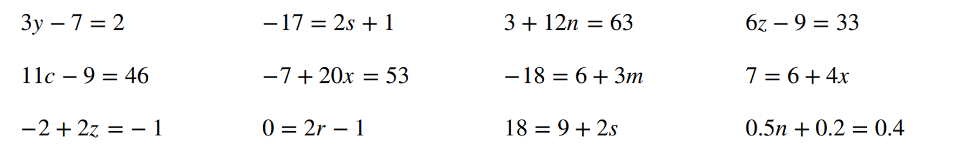  $$y=3$$ | $$s=-9$$ | $$n=5$$ | $$z=7$$
$$c=5$$ | $$x=3$$ | $$m=-8$$ | $$x=\frac{1}{4}$$
$$z=\frac{1}{2}$$ | $$r=\frac{1}{2}$$ | $$s=\frac{9}{2}$$ | $$n=0.4$$

- Solve $\frac{x}{3}+5=8$ by:
- Multiplying both sides first. (Distributive law says to multiply every term).  $$x+15=24$$  $$x=9$$ | - Subtracting 5 from both sides first.  $$\frac{x}{3}=3$$  $$x=9$$
  - You should have gotten the same solution in a and b.
Which method do you prefer?

- Solve $5x+2=17$ by:
- Subtracting 2 from both sides first.  $$5x=15$$  $$x=3$$ | - Dividing both sides by 5 first. (Distributive law says to divide every term).  $$x+\frac{2}{5}=\frac{17}{5}$$  $$x=\frac{15}{5}=3$$
  - You should have gotten the same solution in a and b.
Which method do you prefer?

Mastery
- It is possible to solve $2x+4=20$ by first dividing both sides by 2, as long as every term is divided by 2.
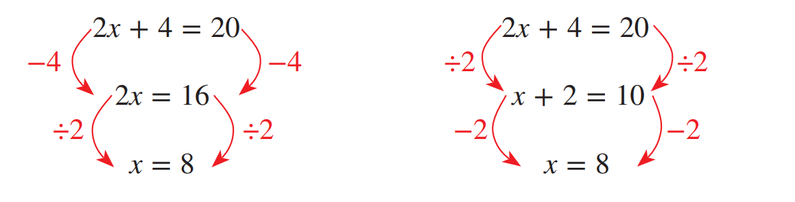

Use this method of dividing first to solve the following equations, and then check that you get the same answer as if you subtracted first.
- $2x+6=12$  $$x=3$$ | - $4x+12=16$  $$x=1$$
- $10x+30=50$  $$x=2$$ | - $2x+5=13$  $$x=4$$
- $5x+4=19$  $$x=3$$ | - $3+2x=5$  $$x=1$$
- $8=2x+4$  $$x=2$$ | - $10=4x+10$  $$x=0$$

- Read the examples carefully and answer the questions.
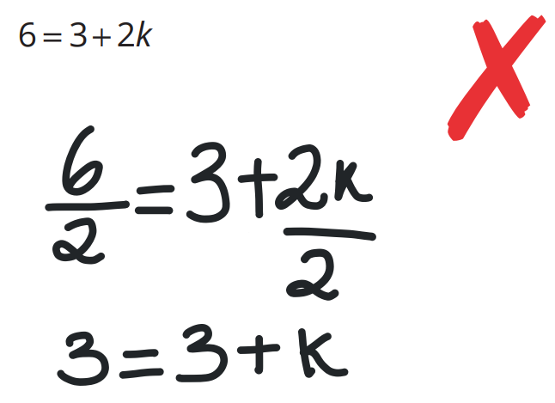  Mackenzie’s work: | If Mackenzie wanted to start by getting rid of the $2$ in $2k$, what should she have done differently?  Divide every term by 2, including the 3.  Solve:  $$6=-3+2k$$  $$k=4.5$$
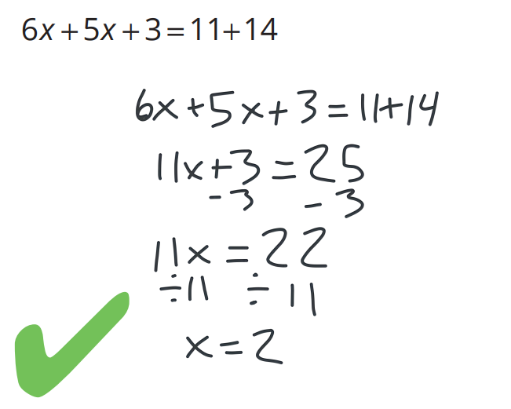  Ken’s work: | In the first step, Ken combined $6x$ and $5x$.  Why didn’t he also add the 3 to get 14x?  3 is not a like term.  Solve:  $$-11=-6x-3x-2$$  $$x=1$$

- Simplify these expressions before solving them.
- $13+2n+2n=41$  $$n=7$$ | - $3n+17+2n=62$  $$n=9$$ | - $3n+7+n-4=35$  $$n=8$$
- $3n+7-n+4=37$  $$n=13$$ | - $2x+37+4-2x=41$  $x$ can be any number | - $3+2n+3n-8=14$  $$n=\frac{19}{5}$$

- When solving $\frac{2x}{3}=10$ we first multiply the denominator, but we could have rewritten the equation as $2\left(\frac{x}{3}\right)$ and divided both sides by 2.
- Solve $2\left(\frac{x}{3}\right)=10$ by dividing first.  $$\frac{x}{3}=5$$  $$x=15$$ | - Solve $\frac{2x}{3}=10$ by multiplying first.  $$2x=30$$  $$x=15$$
  - Hence solve $\frac{147x}{13}=1470$

$$\frac{x}{13}=10$$
$$x=130$$

Two-Step Equations with Negative Coefficients

- Review
- Identify the coefficient of $x$
- $5+2x$ | - $2x-5$ | - $-2x+5$
- $5-2x$ | - $7-3x$ | - $12-x$

- Solve two-step equations
- $4x+3=19$ | - $-7+2x=11$ | - $5+$ $\frac{x}{3}$ $=4$

- Solve one-step equations involving negative coefficients
- $-3x=21$ | - $-x=45$ | - $5-$ $\frac{x}{3}$ $=4$

- Identifying Operations with Negative Coefficients
When a coefficient is negative, the multiplication/division done to $x$ is a negative number.

- Identify operations done to $x$
$$3x+5$$  $$×3,+5$$ | $$-3x+5$$  $$×\left(-3\right), +5$$ | $$5-3x$$  $$×\left(-3\right)+5$$
Identify the operations done to $x$ in the correct order.
- $8-5x$ | - $6-2x$ | - $-3-7x$
- $-3-x$ | - $6-$ $\frac{x}{5}$ | - $3-$ $\frac{x}{7}$

- Identify order of inverse operations to isolate $x$
$$2-3x\underset{→}{ -2 }-3x\underset{→}{ ÷\left(-3\right) }x$$ |  | $$5-\frac{x}{3}\underset{→}{ -5 }-\frac{x}{3}\underset{→}{ ×\left(-3\right) }x$$
Identify the operations required to isolate $x$.
$$2-6x\underset{→}{ } -6x\underset{→}{ }x$$ |  | $$1-\frac{x}{8}\underset{→}{ } -\frac{x}{8}\underset{→}{ }x$$
$$7-4x\underset{→}{ } \underset{→}{ }x$$ |  | $$-2-\frac{x}{13}\underset{→}{ } \underset{→}{ }x$$
$$-3-\frac{x}{5}$$ | $$11-5x$$ |  | $$32-x$$

- Solving Two-Step Equations
To solve equations, we undo operations on $x$ in the opposite order of BIDMAS.
- Undo addition/subtraction done to $x$.
- Undo multiplication/division done to $x$.

- Example Solve two-step equations with negative coefficients
$$3-2x=15$$  $$-3 -3$$  $$-2x=12$$  $÷-2 ÷-2$  $x=-6$ | $$-4-\frac{x}{2}=3$$  $$+4 +4$$  $$-\frac{x}{2}=7$$  $×-2 ×-2$  $x=-14$

- Guided Practice
Solve these equations.
$$4-3x=10$$  …… ……  $-3x$ $=$ ……  …… ……  $x=$ …… | $$5-2x=-1$$  …… ……  $-2x$ $=$ ……  …… ……  $x=$ ……
$3-x=5$  …… ……  …… $=$ ……  …… ……  $x=$ …… | $-$ $\frac{x}{4}$ $-2=3$  …… ……  …… $=$ ……  …… ……  $x=$ ……

- Key Ideas
- A negative coefficient of $x$ means the operation done to $x$ is ………………/……………… by a ……………………… number.

Foundation
- Solve these equations.
- $-2x+18=4$  $$x=7$$ | - $-3a+9=6$  $$a=1$$ | - $-$ $\frac{x}{3}$ $+4=8$  $$x=-12$$ | - $-$ $\frac{x}{2}$ $+1=-10$  $$x=22$$
- $18-2x=4$  $$x=7$$ | - $9-3a=6$  $$a=1$$ | - $4-$ $\frac{x}{3}$ $=8$  $$x=-12$$ | - $1-$ $\frac{x}{2}$ $=-10$  $$x=22$$
You should have gotten the same answer in each column. Explain why.

The equations in each column are the same, the terms are just switched around.
- Read Eliza’s work carefully and answer the questions.
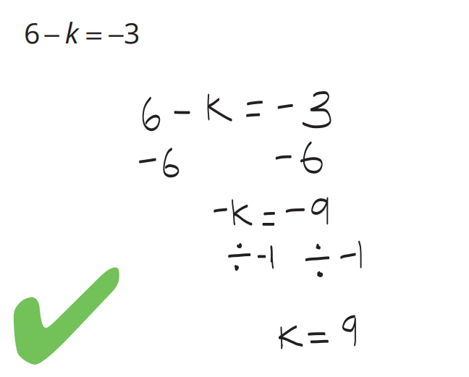  Eliza’s work: | Why did Eliza subtract 6 from both sides of the equation? Why didn’t she add 6?  The 6 term is positive, so we subtract 6.  Why did Eliza divide by –1?  $-k$ means $-1×k$, so we divide by – 1.  Solve:  $$8-k=3$$  $$k=5$$

- Solve these equations.
- $-x+5=12$  $$x=-7$$ | - $5-x=12$  $$x=-7$$ | - $-a-9=6$  $$a=-15$$ | - $-9-a=6$  $$a=-15$$
- $12-x=15$  $$x=-3$$ | - $-2-x=9$  $$x=-11$$ | - $2=-x+9$  $$x=7$$ | - $-8=19-x$  $$x=27$$
- $4x-5=19$  $$x=6$$ | - $\frac{x}{4}$ $-5=19$  $$x=96$$ | - $5-4x=19$  $$x=-3.5$$ | - $5-$ $\frac{x}{4}$ $=19$  $$x=-56$$

Development
- Solve these equations.
- $2x+5=11$  $$x=3$$ | - $4x+100=110$  $$x=2.5$$ | - $4-2x=21$  $$x=-8.5$$
- $2x+7=13$  $$x=3$$ | - $2x+100=110$  $$x=5$$ | - $21=-2x+4$  $$x=-8.5$$
- $2x+10=16$  $$x=3$$ | - $20x+100=110$  $$x=0.5$$ | - $21=-2x+23$  $$x=1$$
- $3x+10=19$  $$x=3$$ | - $2x+3=21$  $$x=9$$ | - $23-2x=21$  $$x=1$$
- $4x+10=22$  $$x=3$$ | - $3+2x=21$  $$x=9$$ | - $\frac{x}{2}-3=21$  $$x=48$$
- $10+4x=22$  $$x=3$$ | - $2x-3=21$  $$x=12$$ | - $3-\frac{x}{2}=21$  $$x=-36$$
- $100+4x=220$  $$x=30$$ | - $-2x+3=21$  $$x=-9$$ | - $0.1x+3=21$  $$x=180$$

Mastery
- Solve these equations involving negative coefficients of $x$.
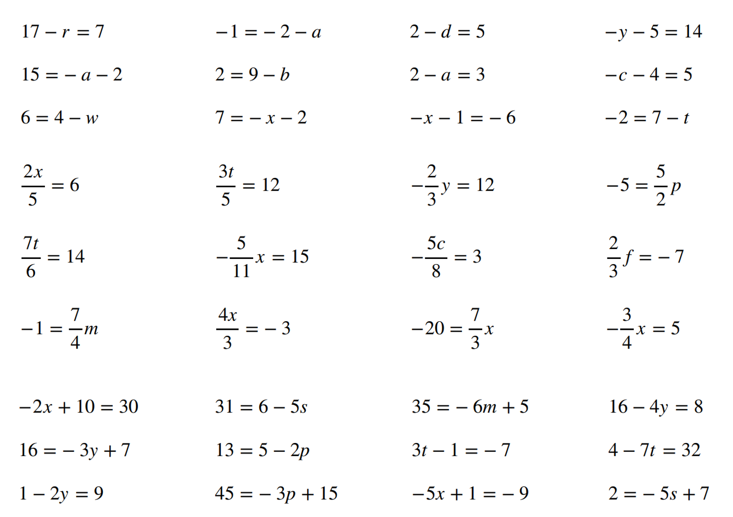  $$r=10$$ | $$a=-1$$ | $$d=-3$$ | $$y=-19$$
$$a=-17$$ | $$b=7$$ | $$a=-1$$ | $$c=-9$$
$$w=-2$$ | $$x=-9$$ | $$x=5$$ | $$t=9$$
$$x=15$$ | $$t=20$$ | $$y=-18$$ | $$p=-2$$
$$t=12$$ | $$x=-33$$ | $$c=-\frac{24}{5}$$ | $$f=-\frac{21}{2}$$
$$m=-\frac{4}{7}$$ | $$x=-\frac{9}{4}$$ | $$x=-\frac{60}{7}$$ | $$x=-\frac{20}{3}$$
$$x=-10$$ | $$s=-\frac{24}{5}$$ | $$m=-5$$ | $$y=2$$
$$y=-3$$ | $$p=-4$$ | $$t=-2$$ | $$t=-4$$
$$y=-4$$ | $$p=-10$$ | $$x=2$$ | $$s=1$$
$$x=0$$ | 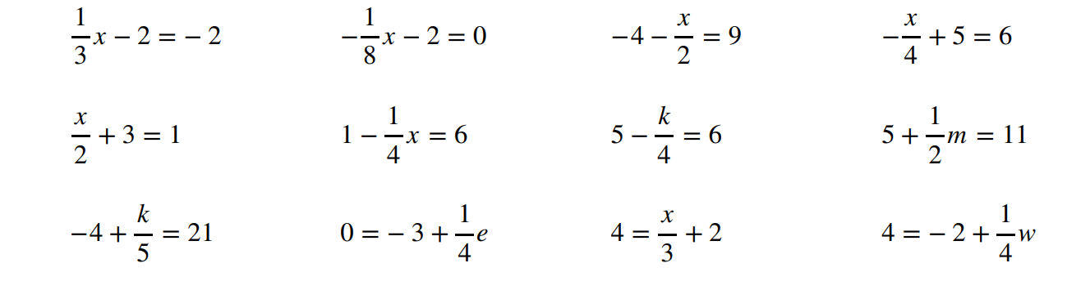  $$x=-16$$ | $$x=-26$$ | $$x=-4$$
$$x=-4$$ | $$x=-20$$ | $$k=-4$$ | $$m=12$$
$$k=125$$ | $$e=12$$ | $$x=6$$ | $$w=24$$

- Consider these three methods of solving $8-4x=12$
Write the inverse operations applied between each line.
$$8-4x=12 \\ -4x=4 \\ x=-1$$ | $$8-4x=12 \\ 8=12+4x \\ -4=4x \\ -1=x$$ | $$8-4x=12 \\ 2-x=3 \\ -x=1 \\ x=-1$$
Which method do you prefer?

Equations with Grouping

- Review
- Evaluate according to order of operations
- $3\left(5\right)+4$ | - $3\left(5+4\right)$ | - $\frac{6}{3}$ $+9$
- $\frac{6+9}{3}$ | - $2\left(7-6\right)$ | - $\frac{8-18}{2}$

- Identifying Operations done to $x$
To undo operations and isolate $x,$ we need to identify what has happened to $x$ and in what order. Operations done to $x$ follow the order of operations.
Brackets
Indices
Division/Multiplication
Addition/Subtraction

- Identify operations done to $x$
$$2\left(x+3\right)$$  $$+3, ×2$$ | $$\frac{x+3}{2}$$  $$+3, ÷2$$ | $$7\left(x-13\right)$$  $$-13,×7$$
Identify the operations done to $x$ in the correct order.
- $3\left(x+5\right)$ | - $5\left(3+x\right)$ | - $4\left(x-3\right)$
- $\frac{x+7}{2}$ | - $\frac{x-11}{5}$ | - $\frac{12+x}{5}$

- Key Ideas
- Operations inside brackets happen …………
- Fractions have ………………… brackets enclosing the numerator and denominator

- Identifying Order of Inverse Operations to Isolate $x$
To solve equations, we undo operations on $x$ in the opposite order of BIDMAS.
Order of operations done to $x$: Order of inverse operations to isolate $x$:
Brackets
Indices
Division/Multiplication
Addition/Subtraction
- Undo operations outside brackets.
- Undo operations inside brackets.

- Identify order of inverse operations to isolate $x$
$$3\left(x-2\right)\underset{→}{ ÷3 }x-2\underset{→}{ +2 }x$$ |  | $$\frac{x+2}{3}\underset{→}{ ×3 }x+2\underset{→}{ -2 }x$$
Identify the operations required to isolate $x$.
$$6\left(x+3\right)\underset{→}{ } x+3\underset{→}{ }x$$ |  | $$\frac{x-8}{5}\underset{→}{ } x-8\underset{→}{ }x$$
$$5(2+x)\underset{→}{ } \underset{→}{ }x$$ |  | $$\frac{x+2}{3}\underset{→}{ } \underset{→}{ }x$$
$$\frac{x-3}{5}$$ | $$5(x-11)$$ |  | $$\frac{x-1}{9}$$
$$7\left(x-10\right)$$ | $$\frac{x-7}{8}$$ |  | $$\frac{-2+x}{3}$$

- Key Ideas
- The first operations we undo are operations ………………… brackets.

- Solving Two-Step Equations involving Grouping
If equations involve grouping, then we undo operations outside brackets first.
- Undo operations outside brackets.
- Undo operations inside brackets.

- Example Solve two-step equations
$$3\left(x+1\right)=15$$  $$÷3 ÷3$$  $$x+1=5$$  $-1 -1$  $x=4$ | $$\frac{x+3}{2}=5$$  $$×2 ×2$$  $$x+3=10$$  $-3 -3$  $x=7$

- Guided Practice
Solve these equations.
$$3(x+2)=18$$  …… ……  $x+2$ $=$ ……  …… ……  $x=$ …… | $$4\left(x-3\right)=8$$  …… ……  ……… $=$ ……  …… ……  $x=$ ……
$$\frac{x+2}{5}=3$$ | $$\frac{x-4}{2}=\frac{1}{2}$$
$$\frac{x-5}{2}=7$$ | $$6\left(x+5\right)=12$$

- Key Ideas
- We isolate $x$ by undoing operations in the ………………… order of BIDMAS.
- We undo ………………/……………… first, then …………………/…………………

Foundation
- Solve these equations.
$$2\left(x+3\right)=14$$  …… ……  $x+3=$ ……  …… ……  $x=$ ……  $$x=4$$ | $$3\left(x+1\right)=18$$  …… ……  …… $=$ ……  …… ……  $x=$ ……  $$x=5$$
$$2\left(x-3\right)=10$$  …… ……  …… $=$ ……  …… ……  $x=$ ……  $$x=8$$ | $$\frac{x+4}{3}=2$$  …… ……  $x+4=$ ……  …… ……  $x=$ ……  $$x=2$$
$$\frac{x+1}{2}=-3$$  …… ……  …… $=$ ……  …… ……  $x=$ ……  $$x=-7$$ | $$\frac{x-3}{4}=1$$  …… ……  …… $=$ ……  …… ……  $x=$ ……  $$x=7$$

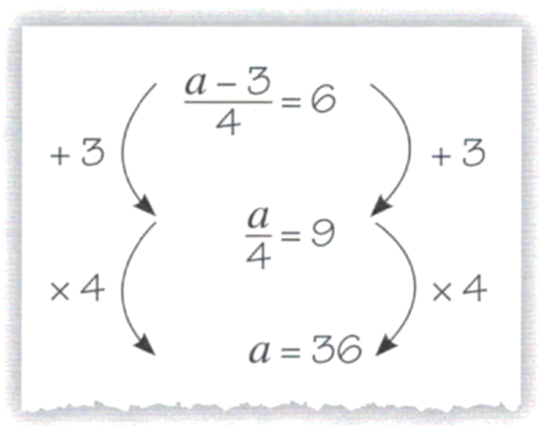
- Jerry is solving the equation $\frac{a-3}{4}$ $=6$
  - Show by substitution that Jericho is wrong

$$\frac{36-3}{4}=\frac{33}{4}≠6$$
  - Explain his mistake

He should have multiplied by 4 first.
  - Find the correct solution to the equation.

$$a=27$$

Development
- Solve these equations, showing all inverse operations.
- $3\left(x+8\right)=36$  $$x=4$$ | - $4\left(x+8\right)=-40$  $$x=-18$$ | - $5(x-8)=40$  $$x=16$$
- $4\left(x+8\right)=36$  $$x=1$$ | - $4\left(x-8\right)=-40$  $$x=-2$$ | - $40=5(x-8)$  $$x=16$$
- $4\left(x+8\right)=40$  $$x=2$$ | - $4\left(x-8\right)=40$  $$x=18$$ | - $40=5(x+8)$  $$x=0$$

- Solve these equations.
- $\frac{x+8}{3}$ $=5$  $$x=7$$ | - $\frac{x+8}{4}$ $=-6$  $$x=-32$$ | - $\frac{x-8}{5}$ $=6$  $$x=38$$
- $\frac{x+8}{4}$ $=5$  $$x=12$$ | - $\frac{x-8}{4}$ $=-6$  $$x=-16$$ | - $6=$ $\frac{x-8}{5}$  $$x=38$$
- $\frac{x+8}{4}$ $=6$  $$x=16$$ | - $\frac{x-8}{4}$ $=6$  $$x=32$$ | - $6=$ $\frac{x+8}{5}$  $$x=22$$

Mastery
- Solve the following two equations.
- $\frac{a}{3}$ $+5=7$  $$a=6$$ | - $\frac{a+5}{3}$ $=7$  $$a=16$$

Explain why the solutions are different.

Order of operations done to $x$ is different.
- Solve these equations.
- $2p+5=60$  $$p=\frac{55}{2}$$ | - $2\left(p+5\right)=60$  $$p=25$$ | - $2\left(2p+5\right)=60$  $$p=\frac{25}{2}$$
- $2\left(5+4p\right)=60$  $$p=\frac{25}{4}$$ | - $2p-5=11$  $$p=8$$ | - $2\left(p-5\right)=11$  $$p=\frac{21}{2}$$

- Describe the mistake made in each of these and provide the correct solution.
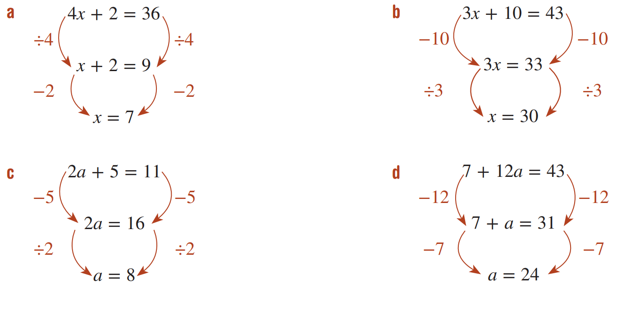  Didn’t divide every term by 4  $$x=\frac{17}{2}$$ | 33÷ 3 = 11  $$x=11$$
11 – 5 = 6  $$a=3$$ | – 12 is the incorrect inverse operation  $$x=3$$

Expanding Method for Equations with Brackets

- Review
- Expand brackets
- $3\left(5+2x\right)$ | - $2\left(4x-5\right)$ | - $7\left(2x-3\right)$
- $4\left(2-3x\right)$ | - $5\left(6-x\right)$ | - $8\left(-3+2x\right)$

- Expand brackets and simplify
- $3\left(4+x\right)+2x$ | - $2\left(3x-6\right)+4$ | - $7\left(5-x\right)+2x$

- Solve two-step equations
- $4x+12=19$ | - $3x+6=18$ | - $2x-10=6$
- $4(x+1)=16$ | - $3\left(x+2\right)=5$ | - $4\left(x-3\right)=10$

- Solving Two-Step Equations involving Brackets
If an equation involves brackets, then we can solve by expanding the brackets first.
- Expand any brackets.
- Simplify by combining like terms, if needed.
- Solve for $x$.

- Example Solve equations with brackets
$$3\left(x+4\right)=21$$  $$3x+12=21$$  $-12 -12$  $3x=9$  $÷3 ÷3$  $x=3$ | $$3\left(x+5\right)+4x=29$$  $$3x+15+4x=29$$  $$7x+15=29$$  $$-15 -15$$  $$7x=14$$  $$÷7 ÷7$$  $x=2$

- Guided Practice
- $2\left(x+5\right)=9$ | - $2\left(x-5\right)=15$
- $3\left(2x-5\right)=18$ | - $3\left(4+3x\right)-4x=32$

- Key Ideas
- We can solve equations like $3\left(x+5\right)=18$ by dividing by ……… first, or ……………… first.

Foundation
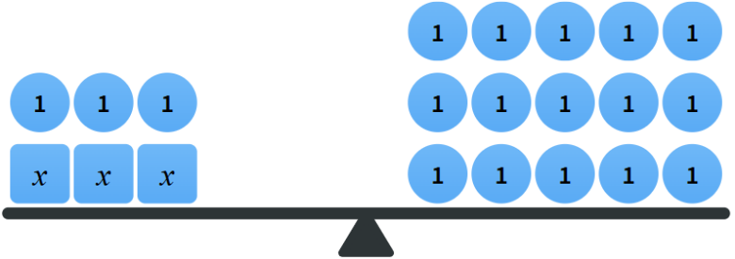
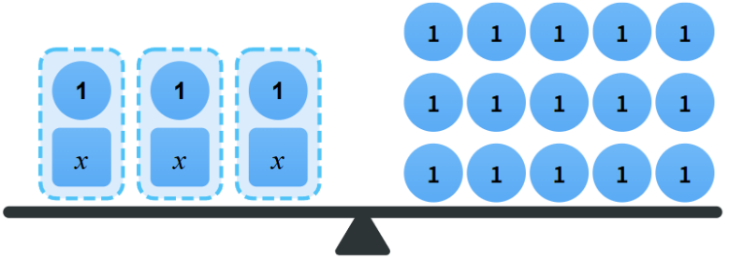
- Compare these two methods of solving $3\left(x+1\right)=18$
Method 1 Method 2

$3\left(x+1\right)=15$ $3x+3=15$
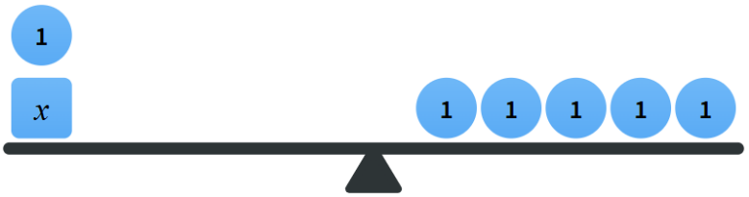
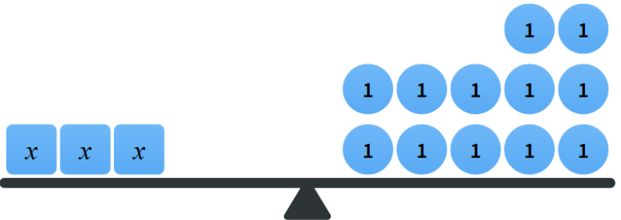
$x+1=5$ $3x=12$
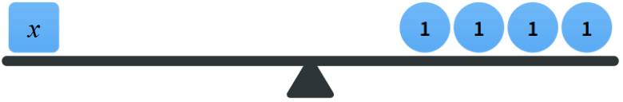
$x=4$ $x=4$
Describe what is different between the two methods.
In method 1, they divided first. In method 2, they expanded first. In this example, method 1 was faster because 18 has a factor of 3.

- Solve these equations by expanding first.
- $2\left(5+l\right)=12$  $10+2l=12$  $$l=1$$ | - $8\left(y+9\right)=72$  $$y=0$$ | - $22=2(b+5)$  $$b=6$$
- $63=7\left(p+2\right)$  $$p=7$$ | - $2\left(r+8\right)=32$  $$r=8$$ | - $8\left(m+7\right)=96$  $$m=5$$
- $3\left(6e+3\right)=27$  $$e=1$$ | - $30=6\left(5r-10\right)$  $$r=3$$ | - $3\left(2q-9\right)=39$  $$q=11$$

- Solve these equations by expanding first.
- $5i+5\left(2+2i\right)=25$  $$i=1$$ | - $3\left(4c-5\right)+c=50$  $$c=5$$ | - $3=2\left(x+4\right)+1$  $$x=-3$$
- $4\left(p-3\right)+p=-32$  $$p=-4$$ | - $2\left(5+x\right)-3x=15$  $$x=-5$$ | - $3\left(r+4\right)+2r+40=2$  $$r=-10$$

Development
- Solve $6(x-9)=24$ by:
- Expanding first.  $$6x-54=24$$  $$6x=78$$  $$x=13$$ | - Dividing both sides by 6 first.  $$x-9=4$$  $$x=13$$
- Solve $6(x-9)=22$ by:
- Expanding first.  $$6x-54=22$$  $$6x=76$$  $$x=\frac{76}{6}=\frac{38}{3}$$ | - Dividing both sides by 6 first.  $$x-9=\frac{22}{6}$$  $$x=\frac{22}{6}+9$$  $$x=\frac{11}{3}+\frac{27}{3}$$  $$=\frac{38}{3}$$
- By considering the two questions above, explain how to determine whether to expand first or divide first when solving equations with brackets.

If dividing first will result in fractions, then we should expand instead.

I’d choose one of the methods for $7\left(a+8\right)=28$
But another for $7\left(a+8\right)=30$

Which method do you think is better for each of these equations? Explain why.

Divide first for $7\left(a+8\right)=28$ as 7 is a factor of 28.
Expand first for $7\left(a+8\right)=30$ as 30 ÷ 7 will result in a fraction.
Use your preferred method to solve:
- $5\left(a+12\right)=100$  $$a=8$$ | - $3\left(b+9\right)=20$  $$b=-\frac{7}{3}$$
- Solve these equations.
- $6x+3=45$  $$x=7$$ | - $6\left(x+3\right)=45$  $$x=\frac{9}{2}$$ | - $6x-3=45$  $$x=8$$ | - $6\left(x-3\right)=45$  $$x=\frac{63}{6}=\frac{21}{2}$$

- Solve these equations using any strategy.
- $2(5m+8)=66$  $$m=5$$ | - $-8(m-3)=32$  $$m=-1$$
- $7\left(3x-1\right)=-13$  $$x=-\frac{2}{7}$$ | - $11(3q+4)=77$  $$q=1$$

- Solve these equations.
- $4\left(x-5\right)=40$  $$x=15$$ | - $4\left(x-5\right)=30$  $$x=\frac{25}{2}$$
- $4\left(x+5\right)+20=40$  $$x=0$$ | - $4\left(x-5\right)+4x=20$  $$x=5$$

Mastery
- Here are Beca's and Jackson's methods for solving the equation $10-4x = 8$
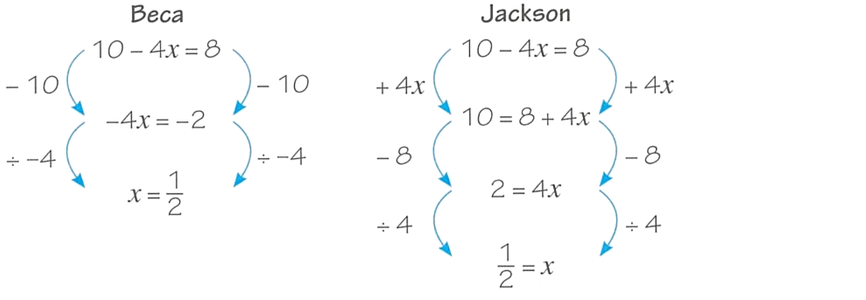

Whose method do you prefer?

Beca’s method is faster, but you need to remember to keep the negative with the $4x$.
Jackson’s method takes longer but you don’t have to work with negatives.
Solve the equations, using your preferred method.
- $16-3x=4$  $$x=4$$ | - $72-7x=51$  $$x=3$$
- $6=10-4x$  $$x=1$$ | - $8-x=13$  $$x=-5$$
- $10-3x=7$  $$x=1$$ | - $10-3\left(x-1\right)=7$  $$x=2$$
- $10-3\left(x+1\right)=7$  $$x=0$$ | - $10-\frac{x+1}{3}=7$  $$x=8$$

Mixed Practice

- Example Solve equations of up to two steps
Example | Your Turn
$$x-6.64=24 \\ +6.64 = +6.64 \\ x=30.64$$ | $$x+0.5=3$$  $x=2.5$ | $$x-\frac{3}{4}=\frac{1}{2}$$  $$x=\frac{5}{4}$$ | $$x+13=-5$$  $$x=-18$$
$$4x=14 \\ ÷4 = ÷4 \\ x=3.5$$ | $$6x=25$$  $$x=\frac{25}{6}$$ | $$-5x=11$$  $$x=-\frac{11}{5}$$ | $$2.5x=-20$$  $x=-8$
$$\frac{x}{4}=14 \\ ×4 = ×4 \\ x=52$$ | $$\frac{x}{6}=5$$  $x=30$ | $$10.2=\frac{x}{5}$$  $x=51$ | $$5=-\frac{x}{4}$$  $x=-20$
$$215x+77=163 \\ -77 = -77 \\ 215x=86 \\ ÷215 = ÷215 \\ x=0.4$$ | $$4x-12=25$$  $$x=\frac{37}{4}$$ | $$3x+52=72$$  $$x=\frac{20}{3}$$ | $$3x-18=-15$$  $x=1$
$$\frac{x}{15}-3=21 \\ +3 = +3 \\ \frac{x}{15}=24 \\ ×15 = ×15 \\ x=360$$ | $$\frac{x}{3}+12=6$$  $x=-18$ | $$12+\frac{x}{2}=8$$  $x=-8$ | $$-2+\frac{x}{6}=3.5$$  $x=33$

- Example Solve equations of up to two steps
Example | Your Turn
$$\frac{4x}{7}=-12 \\ ×7 = ×7 \\ 4x=-84 \\ ÷4 = ÷4 \\ x=-21$$ | $$168=\frac{2x}{5}$$  $x=420$ | $$\frac{3}{5}x=30$$  $x=50$ | $$-\frac{5}{2}x=15$$  $x=-6$
$$22-7x=15 \\ -22 = -22 \\ -7x=-7 \\ ÷-7 = ÷-7 \\ x=1$$ | $$11-2x=15$$  $x=-2$ | $$35=5-7x$$  $$x=-\frac{30}{7}$$ | $$-7-15x=23$$  $$x=-2$$
$$2\left(x-5\right)=13 \\ ÷2 = ÷2 \\ x-5=6.5 \\ +5 = +5 \\ x=11.5$$ | $$3\left(x-16\right)=21$$  $x=23$ | $$4\left(x+16\right)=-84$$  $x=-37$ | $$8\left(1+x\right)=88$$  $x=10$
$$\frac{x-11}{17}=2 \\ ×17 = ×17 \\ x-11=34 \\ +11 = +11 \\ x=45$$ | $$\frac{x-4}{3}=12$$  $x=40$ | $$\frac{6+x}{5}=5.5$$  $x=21.5$ | $$\frac{x-13}{9}=-1$$  $x=4$
$$4x+6\left(2x-4\right)=40 \\ 4x+12x-24=40 \\ 16x-24=40 \\ +24 =+24 \\ 16x=64 \\ ÷16 =÷16 \\ x=4$$ | $$5+3\left(x-2\right)=14$$  $x=5$ | $$4\left(x+6\right)-3x=40$$  $x=16$ | $$-2\left(3-5x\right)+x=16$$  $x=2$

Foundation
- Solve these equations using inverse operations.
- $3x+6=30$  ………… $=$ …………  $x$ $=$ ……  $$x=8$$ | - $-30=3x+6$  $$x=-12$$ | - $3=\frac{-6+x}{30}$  $$x=96$$
- $30=6+3x$  …… $=$ …………  …… $=$ $x$  $$x=8$$ | - $-30=\frac{x}{3}+6$  $$x=-108$$ | - $30=3(x-6)$  $$x=16$$
- $30=6-3x$  …… $=$ …………  …… $=$ $x$  $$x=-8$$ | - $30=6+\frac{x}{3}$  $$x=72$$ | - $30=3(x+6)$  $$x=4$$
- $30=3x-6$  …… $=$ …………  …… $=$ $x$  $$x=12$$ | - $30=\frac{6+x}{3}$  $$x=84$$ | - $30=\frac{1}{3}(x+6)$  $$x=84$$
- $30=-3x-6$  $$x=-12$$ | - $30=\frac{-6+x}{3}$  $$x=96$$ | - $30=-\frac{1}{3}(x+6)$  $$x=-96$$

Development
- Solve these equations. Show each line of working.
- $2x + 5 = -7$ | $-6$ | - $3y - 2 = -13$ | $$-\frac{11}{3}$$
- $23 = 4 - 7x$ | $$-\frac{19}{7}$$ | - $\frac{4x}{3}=-9$ | $$-\frac{27}{4}$$
- $7 = 3a + 2$ | $$\frac{5}{3}$$ | - $4b + 7 = 25$ | $4.5$
- $7y - 3 = -8$ | $$-\frac{5}{7}$$ | - $2a+\frac{1}{2}=\frac{1}{4}$ | $$-\frac{1}{8}$$
- $-1=5n-\frac{1}{4}$ | $$-\frac{3}{20}$$ | - $\frac{x}{3}-7=-12$ | $-15$
- $\frac{s}{2}-3=-7$ | $-8$ | - $2 - 5x = 9$ | $$-\frac{7}{5}$$
- $\frac{2x}{5}=-3$ | $$-\frac{15}{2}$$ | - $5+\frac{3d}{2}=-7$ | $-8$
- $5(y - 7) = -12$ | $$\frac{23}{5}$$ | - $4(5 - b) = 18$ | $$\frac{1}{2}$$
- $3-\frac{4z}{3}=5$ | $$-\frac{3}{2}$$ | - $\frac{4+y}{3}=-2$ | $-10$
- $\frac{6+b}{2}=-3$ | $-12$ | - $\frac{7x-3}{3}=9$ | $$\frac{30}{7}$$
- $5=\frac{3b-6}{2}$ | $$\frac{16}{3}$$ | - $2(x+3)=11$ | $$\frac{5}{2}$$
- $7(2a+1)=8$ | $$\frac{1}{14}$$ | - $5(3-2x)=6$ | $$\frac{9}{10}$$
- $2\left(x-3\right)-3x=4$ | $-10$ | - $7(2z+1)+3=80$ | $$5$$
- $60=3y+2(y+5)$ | $10$ | - $3\left(2x+3\right)-1-4x=4$ | $$-2$$

Mastery
- Solve these equations.
Note that these equations may require 3 steps or more.
- $\frac{2y}{5}-7=11$  $$y=45$$ | - $\frac{3x}{4}+1=12$  $$x=\frac{44}{3}$$ | - $-4m-8=3$  $$m=-\frac{11}{4}$$
- $72=\frac{7x}{5}-12$  $$x=60$$ | - $\frac{n}{5}+2=5$  $$n=15$$ | - $\frac{3y}{5}+8=2$  $$y=-10$$
- $1=\frac{-2u-3}{5}$  $$u=-4$$ | - $-2=\frac{4d}{5}+2$  $$d=-5$$ | - $0=12+\frac{2u}{5}$  $$u=-30$$
- $3\left(\frac{2x+9}{4}\right)-5=7$  $$x=\frac{7}{2}$$ | - $7\left(\frac{4y-3}{9}\right)+5=17$  $$y=\frac{129}{28}$$ | - $4\left(2x+3\right)-3\left(4x+5\right)=0$  $$x=-\frac{3}{4}$$

Writing Equations from Scenarios

- Review
- Write expressions from a scenario
- 3 more than $x$ | - $5$ lots of $x$ | - 2 less than $x$
- $x$ divided by 14 | - Double $x$, then add 7 | - Add 7 to $x$, then double the result
- 3 more than half of $x$ | - Halve $x,$ then add 3 | - The sum of $x$ and $5$ is multiplied by 3

- Identify operations from a scenario
- A bag contains $x$ lollies, and 7 are taken out. How many are left in the bag? | - A class has $x$ girls and 12 boys.  How many students are in the class?
- On a table there are 3 bags, each with $x$ lollies, and 5 loose lollies. How lollies are on the table? | - A $10 tip is added to a restaurant bill of $\$x$. Then the entire bill is split between 4 friends.
- Julie earns $$x$ per hour. She works 5 hours and earns a bonus of $20. How much does she earn in total? | - A taxi costs $10 to start and $8 per kilometre.  Write an expression to represent the cost of a trip of distance $n$ kilometres.

- Example Write equations from a scenario
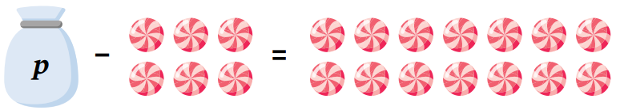  After 6 lollies are taken out of a bag of $p$ lollies, there are still 14 left.  $$p-6=14$$ | $p$ represents the ………………… of lollies in the bag.  In this scenario, $p$ does not represent any value, it represents a ……………… value.
Subtracting 5 from a number, $x$, is 22.  $$x-5=22$$ | $5-x=22$ is incorrect because the word “…………” tells you to switch the order of the numbers.
A wallet has $$x$ in it. The amount of money is halved and then $10 is added to it, the resulting amount is $25  $$\frac{x}{2}+10=25$$ | Half of a number represented by $\frac{x}{2}$because multiplying by half is the same as ……………… by 2.

- Guided Practice
Write equations for these scenarios.
- After adding 2 coins to a bag of $a$ coins, there are 6 coins in total.  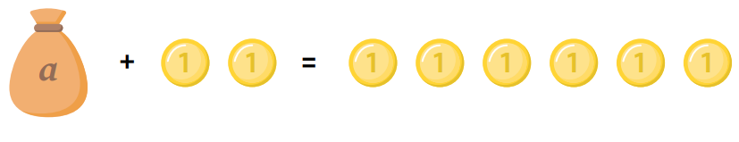 | 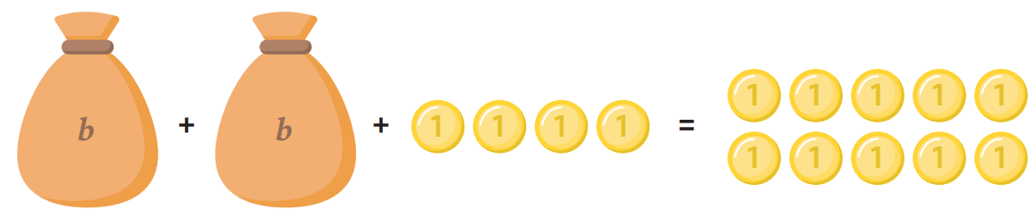  - Two bags of $b$ coins and 4 loose coins is worth the same as 10 coins.
- The sum of a number $x$ and 7 is 20 | - The number of cards in a deck is $x$.  In 7 decks there are 56 cards.
- Prim is currently $p$ years old.  In 5 years she’ll be 18. | - Three boxes of $x$ pencils and 5 loose pencils makes 26 pencils in total.

Foundation
- $b$ represents the number of apples in each box. Write an equation for each scenario.
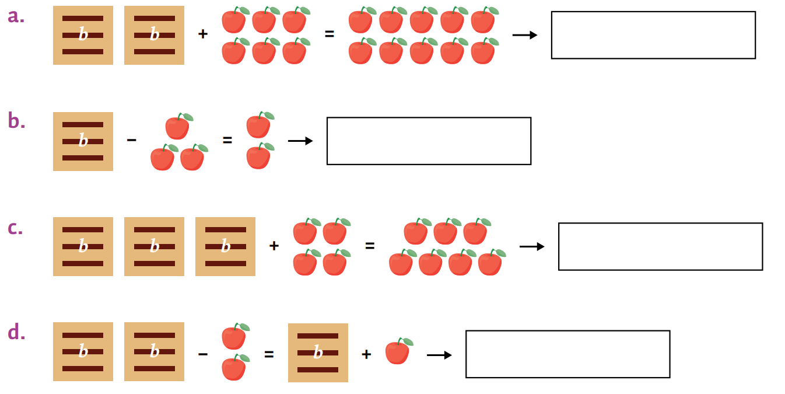  ……………………………… = …………………  $$2b+6=10$$ | ………………………………… = ………………  $$b-3=2$$
……………………………………………………  $$3b+4=7$$ | ……………………………………………………  $$2b-2=b$$
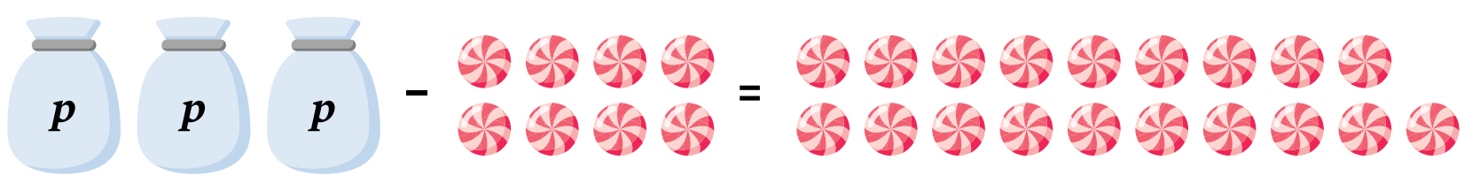

  - Write an equation describing this scenario.

$$3p-8=19$$
  - What might $p$ represent?
Number of lollies in each bag
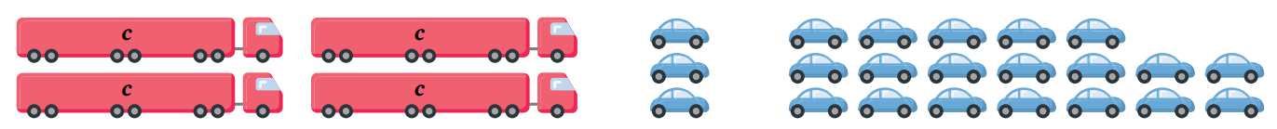

  - Write an equation describing this scenario.

$$4c+3=19$$
  - What might $c$ represent?
Number of cars in each truck
- Write equations for these scenarios.
- The sum of 3 and $x$ is equal to 10.  $$3+x=10$$ | - When $k$ is multiplied by 5,  the result is 1005.  $$5k=1005$$
- When $d$ is doubled, the result is 78.  $$2d=78$$ | - The product of 8 and $x$ is 56.  $$8x=56$$
- When $p$ is tripled, the result is 21.  $$3p=21$$ | - One-quarter of $t$ is 12.  $$\frac{t}{4}=12$$
- Write an equation to represent these statements.
- 8 less than $t$ is equal to 14  $$t-8=14$$ | - Half of ​𝑦​ is 13  $$\frac{y}{2}=13$$
- 45 is 3 times greater than $x$  $$45=3x$$ | - The value of $a$ is 4 times greater than the sum of 8 and 12  $$a=4\left(8+12\right)$$
- A quarter of z is 3 larger than 12  $$\frac{z}{4}=12+3$$ | - One-fifth of double of $t$ is 12.  $$\frac{2t}{5}=12$$
- Chairs cost $$c$ at a store. The cost of 6 chairs is $546.  $$6c=546$$ | - Amy is $f$ years old. In 10 years’ time her age will be 27.  $$f+10=27$$

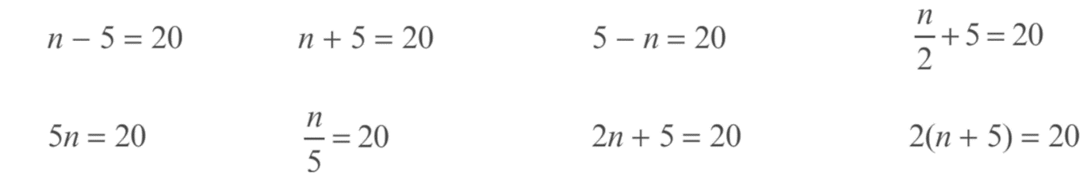
- Match the sentence to the equation. Each equation can be used more than once.

- A number is increased by 5 to give 20
$$n+5=20$$
- Five times a number is 20.
$$5n=20$$
- Dividing a number by 5 gives 20.
$$\frac{n}{5}=20$$
- A number is doubled and then 5 is added to give 20.
$$2n+5=20$$
- A number is increased by 5 and then the result is doubled to give 20.
$$2\left(n+5\right)=20$$
- What number can be subtracted from 5 to give 20?
$$5-n=20$$
- The sum of a number and 5 is 20.
$$n+5=20$$
- A number is halved, then 5 is added to give 20.
$$\frac{n}{2}+5=20$$
- The product of 5 and a number is 20.
$$5n=20$$
- One-fifth of a number is 20.
$$\frac{n}{5}=20$$
- A number is decreased by 5 to give 20.
$$n-5=20$$
- Five more than half of a number is 20.
$$\frac{n}{2}+5=20$$

Development
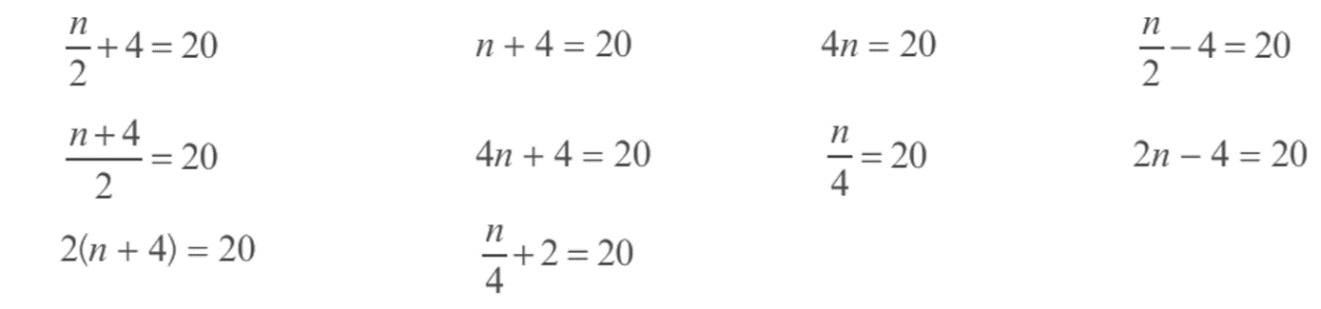
- Match the number sentence to the equation.

- Twice a number is decreased by 4 to give 20.
$$2n-4=20$$
- 4 more than four times a number is 20.
$$4n+4=20$$
- Dividing a number by 4 gives 20.
$$\frac{n}{4}=20$$
- A number is doubled, then 4 is subtracted to give 20.
$$2n-4=20$$
- A number is increased by 4, then the result is doubled to give 20.
$$2\left(n+4\right)=20$$
- The sum of a number and 4 is 20.
$$n+4=20$$
- A number is halved, then 4 is added to give 20.
$$\frac{n}{2}+4=20$$
- The product of 4 and a number is 20.
$$4n=20$$
- A number is increased by 4, then the result is halved to give 20.
$$\frac{n+4}{2}=20$$
- A number is increased by 4 to give 20.
$$n+4=20$$
- 4 less than half of a number is 20.
$$\frac{n}{2}-4=20$$
- 2 more than a quarter of a number is 20.
$$\frac{n}{4}+2=20$$
- Write an equation to represent these scenarios.
- Each class has the same number (𝑥)​ of students in it. There are six classes with a total of 132 students.  $$6x=132$$ | - 12 students shared b books equally. Each student received 9 books.  $$\frac{b}{12}=9$$
- Ronnie has a number of basketball cards ($r$). The number of basketball cards Mick has ($m$) is 4 more than Ronnie.  $$m=r+4$$ | - There are $p$ lollies in a bag. Gilbert bought 7 bags and ate 5 lollies. He then has 128 lollies left.  $$7p-5=128$$
- Lola placed $c$ cookies on a tray for baking. Charlie added four more cookies to Lola’s tray. They then tripled the number of cookies to make 32 cookies.  $$3\left(c+4\right)=32$$ | - Simon had $d$ stickers, he took 4 for himself before sharing the rest between 3 friends. Each friend got 9 stickers each.  $$\frac{d-4}{3}=9$$

Mastery
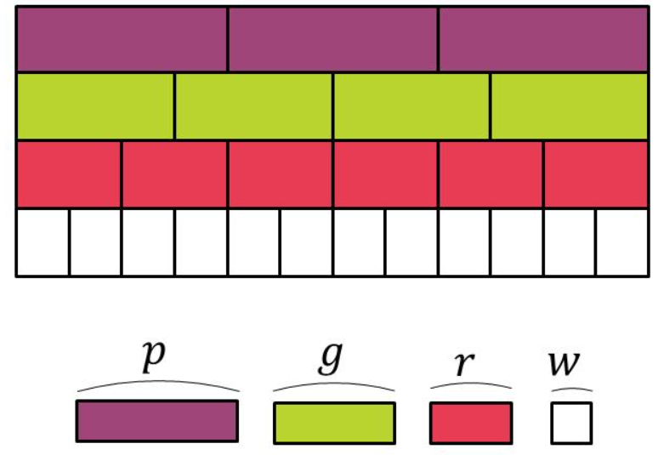
- Consider these rods, laid end to end. The pronumeral represents the length of a rod.

Use the diagram to answer these questions. Circle one option in each question.
- $3r=$ …………
 | $p$ |  | $3w$ |  | $2p$ |  | $2g$
2g
- $2p=$ …………
 | $3g$ |  | $5r$ |  | $8w$ |  | $8r$
8w
- $2w+r=$ …………
 | $p$ |  | $4p$ |  | $2p$ |  | $\frac{p}{2}$
p
- $2g+3r=$ …………
 | $14w$ |  | $6p$ |  | $3p$ |  | $10w$
3p
- $6g=$ …………
 | $5p$ |  | $8r$ |  | $9r$ |  | $4p$
9r
- $8r=$ …………
 | $6g$ |  | $4p$ |  | $14w$ |  | $5g$
4p
- Jo says $w=\frac{g}{3}$. Paul says $w=4p$. Who is correct?
 | Only Jo |  | Only Paul |  | Both |  | Neither
Only Jo
- Jo says: $3\left(2w+r\right)=4g$. Paul says: $2\left(p+2w\right)=4g$. Who is correct?
 | Only Jo |  | Only Paul |  | Both |  | Neither
Both

Problem-Solving using Equations

- Solving Problems using Equations
- Let a pronumeral, like $x$, represent the unknown quantity.
- Write an equation describing the scenario.
- Solve the equation.
- Check the answer makes sense and include units.

- Example Model and solve word problems using equations
When Adam adds his current age and his age next year, the result is 27.  How old is he now?  1. Let $a$ be Adam’s current age.  2. $a+\left(a+1\right)=27$3. $2a+1=27$ $2a=26$ $a=13$  4. Adam is 13 years old this year. | Asher works for 12 hours this week.  He earned a wage and a bonus of $50.  If he earned $410 in total,  how much does he make an hour?  1. Let $n$be how much he makes an hour.  2. $12n+50=410$3. $12n=360$ $n=30$  4. Asher makes $30 an hour.

- Guided Practice
- When Mila adds her current age and her age last year, the result is 23.  How old is she now?  1. Let …… be …………………………  2.  3.  4. | - Charlotte earned $180 total this week.  If this includes a $60 bonus and she earns $15 an hour, how many hours did she work this week?  1. Let …… be …………………………  2.  3.  4.

Foundation
- The sum of the ages of Sam and his brother Bernard is 34.
If Sam is 4 years older than Bernard, find their ages.
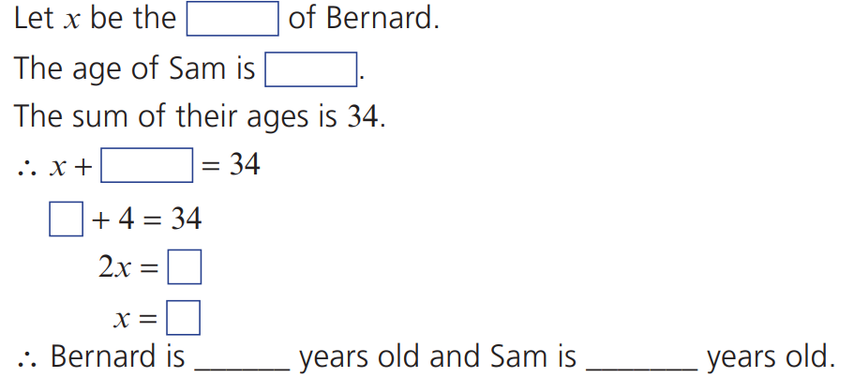

15 and 19
- There are 12 less boys than girls in a choir.
There are 48 students altogether in the choir.
Find the number of girls in the choir.
Let $x$ be the number of girls.
The number of boys is $x-$……
Equation: $x+($ ) $=$ ……
$$x+\left(x-12\right)=48$$
30 girls
- The total price of three pens and one pencil is 99 cents.
The pencil costs 18 cents.
Let the price of one pen be $x$ cents.
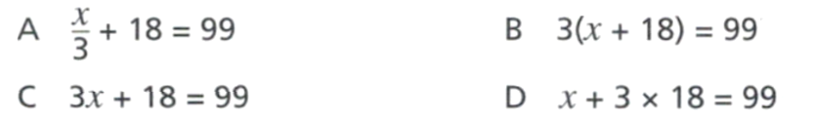
Which of these equations represents the information given?

C
Solve the correct equation to find the price of one pen.

27 cents
- Jonas is paid $15 per hour and gets paid a bonus of $50 each week.
One week he earned $425. Calculate how many hours Jonas worked that week.
  - Let $n$ be the number of hours Jonas worked.
Write an equation relating the information given.

$$15n+50=425$$
  - Solve the equation for $n$.

25 hours
- The sum of Kate’s age now, and her age next year, is 47.
How old is Kate?
Let $x$ be Kate’s current age.
$x+(x+1)=47$

$$x+\left(x+1\right)=47$$
23 years old
- The sum of the ages of two sisters Katie and Kathy is 28.
If Kathy is 4 years older than Katie, find their ages.
Let $x$ be the age of Katie.

$$x+\left(x+4\right)=28$$
Katie is 12, Kathy is 16
- A prize of $1000 is divided between Asher and Leo.
Asher receives $287 more than Leo.
How much did Leo receive?
Let $x$ be

Let $x$ be Leo’s money
$$x+\left(x+287\right)=1000$$
$356.50
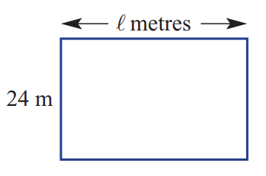
- This rectangular paddock has an area of 720 m. Find the length.

$$A=lw$$
$$720=24l$$
$l=$ 30 m
- A prize of $1000 is divided between Adele and Benita so that Adele receives $285 more than Benita. How much did each person receive?

Let $x$ be Benita’s money
$$x+\left(x+285\right)=1000$$
Benita: $357.50
Adele: $642.50
- A taxi ride is $10 flag fall and $2.50 per kilometre.
How many kilometres did you travel if the final cost was $220?

Let $x$ be number of km travelled.
$$10+2.5x=220$$
$x=84$ kilometres
- Jane and Luke have a combined age of 60.
Given that Jane is twice as old as Luke, find the ages of Luke and Jane.

Let $x$ be Luke’s age.
$$x+2x=60$$
Luke is 20, Jane 40
- Alice buys four copies of a game.
She also buys a gaming accessory for $160.
She spent a total of $388.
How much was the game?

Let $x$ be price of game
$$4x+160=388$$
The game was $57
- Two people are eating at a restaurant.
A fancy dish costs three times as much as a regular dish.
If they order one of each and the total bill is $68, how much is the fancy dish?

Let $x$ be price of regular dish
$$x+3x=68$$
$$x=17$$
Fancy dish is $51
- A theme park charges $18 for a child ticket.
The total cost of two adult tickets and three child tickets is $110.
  - Find the value of an adult ticket.

Let $x$ be price of adult ticket.
$$2x+3\left(18\right)=110$$
$$x=\$28$$
  - Find the cost for a party of 6 adults and 13 children to visit the theme park.

$$6\left(28\right)+13\left(18\right)=\$402$$

- Molly is paid $19.50 an hour and gets paid a bonus of $65 each week.
One week she earned $786.50.
How many hours did she work?

$$19.5n+65=786.5$$
$n=37$ hours

Development
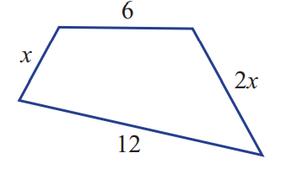
- The perimeter of the shape shown is 30.
  - Find the value of $x$ by forming an equation.

$$x+6+2x+12=30$$
$$x=4$$
  - Explain why it is impossible for the perimeter to be 17.
$$3x+18=17$$
$$x=-\frac{1}{3}$$
The side length would be negative.
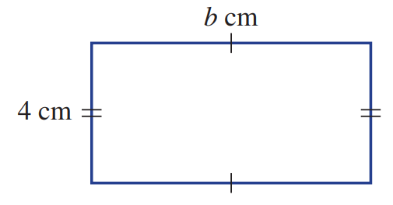
- Determine the breadth of this rectangle if the perimeter is 72.7 cm.

$$2b+8=72.7$$
$$b=32.35 cm$$
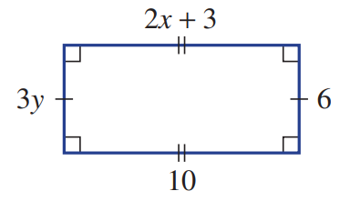
- Find the values of $x$ and $y$ in the rectangle shown.

$$3y=6, y=2$$
$$2x+3=10, x=3.5$$

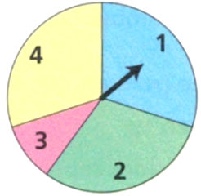
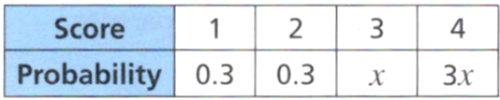
- The spinner is spun once. The table shows the probabilities that it lands on 1, 2, 3 or 4.

  - Find the value of $x$. (hint: the sum of all probabilities is 1)

$$0.3+0.3+x+3x=1$$
$$x=0.1$$
  - Find the probability that the spinner lands on an even number.

$$Probability of 2+Probability of 4=0.3+0.3=0.6$$
- The equal sides of an isosceles triangle are 12 cm long.
The perimeter is 35 cm. How long is the third side?

Let third side be $x$
$$x+12+12=35$$
$$x=11 cm$$
- In a rectangle, one side is 4 times as long as the other.
The perimeter is 60 cm. How long is the shorter side?

Let $x$ be length of shorter side
$$x+x+4x+4x=60$$
$$x=6 cm$$
- In a rectangle, one side is 4 cm longer than the other.
The perimeter is 60 cm. How long is the shorter side?

Let $x$ be length of shorter side
$$x+x+\left(x+4\right)+\left(x+4\right)=13 cm$$
$x=13 cm$

- In an isosceles triangle, one side is 3 cm longer than the equal sides.
The perimeter is 60 cm. How long are the sides?

Let $x$ be shorter side
$$x+x+\left(x+3\right)=60$$
$$x=19$$
19 cm, 19 cm, 22 cm
- I can buy 3 rulers and 4 pencils for $13.50.
The pencils cost $1.50 each. What is the price for each ruler?

Let $x$ be price of ruler
$$3x+4\left(1.5\right)=13.50$$
$$x=2.5$$
$2.50 per ruler

- A 50 m long rope is cut into four pieces.
Three of them are equal but the other is 6 m shorter. How long are the pieces?

Let $x$ be longer pieces.
$$x+x+x+\left(x-6\right)=50$$
$$x=14$$
Pieces are 14 m and 8 m
- A rectangular paddock has an area of 720 m.
One of the sides is 22.5 m. Calculate its perimeter.
Let $x$ be other side
$$22.5x=720$$
$$x=32$$
$$P=32+32+22.5+22.5$$
$$=109 m$$
- Sarah is $x$ years old. Thomas is 3 years older than Sarah. David is twice as old as Sarah.
The total of their ages is 51. How old is Sarah?

$$x+\left(x+3\right)+2x=51$$
$$x=12$$
Sarah is 12
- Rayyan buys 3 identical pens from a shop. For each pen he was given a 12-cent discount.
He paid $25 and got $1.36 change. How much was each pen?

Let $x$ be pen without discount
$$3\left(x-0.12\right)=25-1.36$$
$$x=8$$
Each pen is $8
- Maya, Charlotte, and Emma are sharing $1850. They don’t share it evenly.
Let Emma’s share be $x$.
Charlotte gets $400 more than Emma.
Maya gets $350 less than double Emma’s share.
How much does each person receive?

$$x+\left(x+400\right)+\left(2x-350\right)=\$1850$$
$$x=\$450$$
Emma gets $450
Charlotte gets $850
Maya gets $550
- Shay recorded three songs, A, B and C.
Song B is 40 seconds longer than song A.
Song C is twice as long as song A.
The total length of the three songs is 680 seconds.
Work out the length of song B. Give your answer in minutes and seconds.

Let $x$ be length of song A
$$x+\left(x+40\right)+2x=680$$
$$x=160$$
Song B is 200 seconds long

Mastery
- Consider this shape.
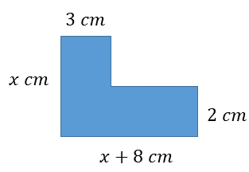
  - Find the perimeter if $x=5$.
$$x+3+\left(x-2\right)+\left(x+5\right)+2+\left(x+8\right)$$
$$=4x+16$$
$$=4\left(5\right)+16$$
$=36$ cm

  - Find the area if $x=7$.

$$A=3x+2\left(x+5\right)$$
$$A=3\left(7\right)+2\left(7+5\right)$$
$=45$ cm²
  - The perimeter is 46 cm. Find the value of $x$.

$$4x+16=46$$
$$x=7.5 cm$$

  - The area of the shape is 65 cm². Find the value of $x$
$$3x+2\left(x+5\right)=65$$
$x=11$ cm

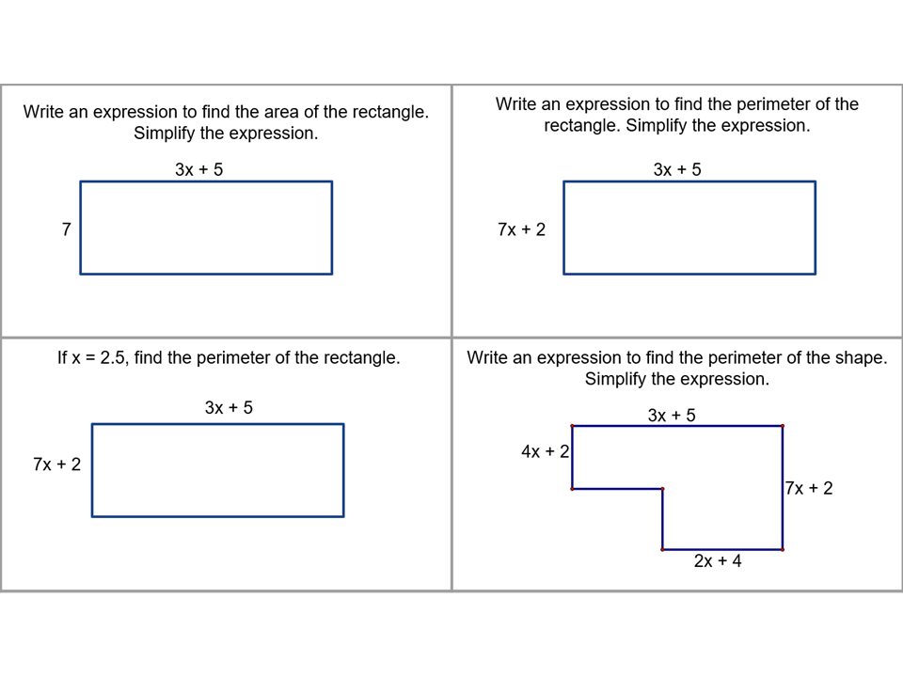  - Write an expression to find the perimeter of the rectangle. Simplify the expression  $$20x+14$$ | - If $x=2.5$, find the perimeter of the rectangle.  $64$ cm
- Write an expression to find the perimeter of the shape. Simplify the expression.  $$20x+14$$ | - Determine the value of $x$ if the perimeter is 64 cm.  $2.5$cm

- Consecutive integers are numbers that occur one after the other, such as 5, 6, 7.
Any number can be represented as $n$
Consecutive numbers would $n, \left(n+1\right), \left(n+2\right)…$
- The sum of three consecutive integers is 261. Find the integers.  $$n+\left(n+1\right)+\left(n+2\right)=261$$  $$n=86$$  86, 87, 88 | - The sum of three consecutive integers is 342. Find the integers.  113, 114, 115
Consecutive even numbers are even numbers that occur one after the other, such as 14, 16, 18
Any even number can be represented as $2n$.
Consecutive even numbers would be $2n, (2n+2), (2n+4), (2n+6)…$
- Find three consecutive even numbers that add up to 42  $$2n+\left(2n+2\right)+\left(2n+4\right)=42$$  $$n=6$$  12, 14, 16 | - Find four consecutive even numbers that add up to 52.  10, 12, 14, 16
Consecutive odd numbers are odd numbers that occur one after the other, such as 11, 13, 15
Any odd number can be represented as $2n+1$.
Consecutive odd numbers would be $2n+1, (2n+3), (2n+5), (2n+7)…$
- Find three consecutive odd numbers that add up to 57.  $$\left(2n+1\right)+\left(2n+3\right)+\left(2n+5\right)=57$$  $$n=8$$  $$17, 19, 21$$ | - Find four consecutive odd numbers that add up to 48.  9, 11, 13, 15
- Four consecutive numbers add up to 27.
  - Find the integers.

$$n=5.25$$
  - What do you notice? What does this mean?

$n$ is a decimal, so it is impossible for 4 consecutive integers to add to 27.

Equations with $x$ on Both Sides

- Equations with $x$ on Both Sides
If an equation has $x$ on both sides, we first want $x$ terms on only one side.
We do this by adding or subtracting a multiple of $x$ from both sides.
- We should add or subtract so that the resulting coefficient of $x$ is positive.

- Identify operation to eliminate $x$ on one side
$$5x+1=3x+7$$  $$-3x -3x$$  $2x+1=7$ | $$3x+1=5x+7$$  $$-3x -3x$$  $1=2x+7$ | $$1-5x=3x+7$$  $$+5x +5x$$  $1=8x+7$
Identify the multiple of $x$ to add or subtract.
- $2x+5=x+8$ | - $x+8=2x+5$ | - $8-x=2x+5$
- $8-x=2x-5$ | - $x+8=2x-5$ | - $2x+8=4x+5$
- $2x+8=5-4x$ | - $8-2x=5-4x$ | - $8-2x=-4x+5$

- Key Ideas
- When $x$ appears on both sides, we want to change the equation so that all $x$ terms are on …………… side.
- We do this by adding or subtracting a ………………… of $x$ from both sides.
- We want to keep the coefficient ………………… so the solving is easier.

- Solving Equations with $x$ on Both Sides
- Add or subtract a multiple of $x$ so $x$ terms are only on one side.
Try to make the coefficient of $x$ positive, if possible.
- Solve for $x.$

- Example Solve equations with pronumerals on both sides
$$2x+5=x+8$$  $-x -x$  $x+5=8$  $-5 -5$  $x=3$ | $$2x+7=5x+1$$  $-2x -2x$  $7=3x+1$  $-1 -1$  $6=3x$  $÷3 ÷3$  $2=x$

- Guided Practice
$$3x+2=x+6$$ | $$2x+12=5x$$
$$5x-3=2x+7$$ | $$7x=12-5x$$
$$5x+12=16+4x$$ | $$6x=27-3x$$

Foundation
- Fill in the missing operation.
$$4x-2=3x+3$$  …… ……  $$x-2=3$$  $$-3x$$ | $$2+4x=5x+1$$  …… ……  $$2=x+1$$  $$-4x$$

- Complete the following.
$$5x+3=2x+8$$  $$-2x -2x$$  ……… $=$ ………  $$3x+3=8$$ | $$9x+5=12x+21$$  $$-9x -9x$$  ……… $=$ ………  $$5=3x+21$$
$$2x+9=5-2x$$  $$+2x +2x$$  ……… $=$ ………  $$4x+9=5$$ | $$15x+12=13-7x$$  $$+7x +7x$$  ……… $=$ ………  $$22x+12=13$$
$7x=3x+4$  …… $=$ 4  $$4x$$ | $9x+2=5x+10$  ……… $= 10$  $$4x$$
$4x+2=8-2x$  ……… $=8$  $$6x$$ | $2-3x=5x+4$  $2 =$…………  $$8x+4$$

- Consider the balance model.
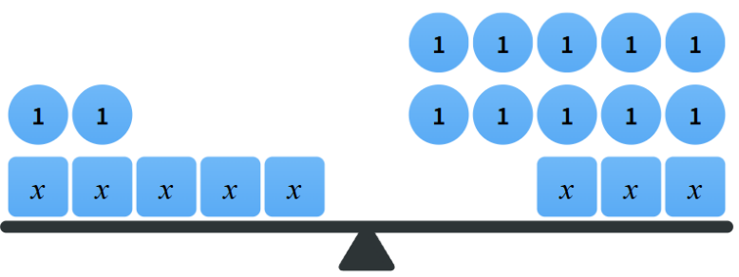
  - What equation does this show?
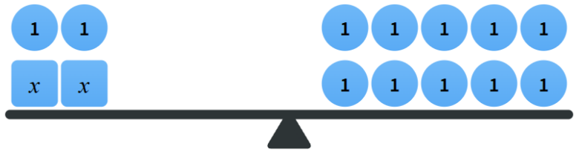
$$5x+2=3x+10$$
  - $3x$ can be subtracted from each side.
What equation is shown now?

$$2x+2=10$$
  - Solve the equation you wrote for part b.

$$x=4$$
  - Verify your solution by substituting into LHS and RHS of the original equation.
LHS = $5x+2=22$
RHS = $3x+10=22$

- Solve these equations.
$$3x=x+6$$  …… ……  $$2x=6$$  …… ……  $x=$ ………  $$x=3$$ | $$2x+1=x+4$$  …… ……  …… $=$ ………  …… ……  $x=$ ………  $$x=3$$
$$x+2=5x$$  …… ……  …… $=4x$  …… ……  …… $=x$  $$x=\frac{1}{2}$$ | $$x-4=3x$$  …… ……  …… $=$ $2x$  …… ……  …… $=x$  $$x=-2$$
$5x+6=x+10$  …… ……  …… $=$ ………  …… ……  …… $=$ ………  …… ……  $x=$ ………  $$x=1$$ | $4x+8=6x-2$  …… ……  $8 =$ ………  …… ……  …… $=$ ………  …… ……  …… $=$ $x$  $$x=5$$

- Solve these equations.
- $7y=5y+9$  ……… ………  ………… $=$ …………  ……… ………  ……… $=$ ………  $$y=4.5$$ | - $3k=k+8$  ……… ………  ………… $=$ …………  ……… ………  ……… $=$ ………  $$k=4$$
- $3x+6=2x+9$  ……… ………  ………… $=$ …………  ……… ………  ……… $=$ ………  $$x=3$$ | - $10k=12-8k$  ……… ………  ………… $=$ …………  ……… ………  ……… $=$ ………  $$k=\frac{2}{3}$$
- $3a+6=a+18$  $$a=6$$ | - $6n+5=2n+17$  $$n=3$$
- $5x-3=2x+6$  $$x=3$$ | - $3d-6=d-4$  $$d=1$$
- $3m+5=-m+26$  $$m=\frac{21}{4}$$ | - $4x+3=-2x+7$  $$x=\frac{2}{3}$$

Development
- Ashley and Amelia are solving the equation $8x+3=2x+21$
I’m going to subtract $2x$ from both sides first


I’m going to subtract $8x$ from both sides first

Solve the equation using both methods.
$$6x+3=21$$  $$6x=18$$  $$x=3$$ | $$3=-6x+21$$  $$-18=-6x$$  $$3=x$$
Which method do you prefer?

Ashley’s method avoids negative coefficients of $x$.


- Emma and Harriet are solving the equation $10-3t=2+5t$
I'm going to subtract $5t$ from both sides.
I'm going to add $3t$ to both sides.

Whose strategy is most sensible? Explain why

The second method avoids negative coefficients of $x$.
Solve the equation using both methods.
$$10-8t=2$$  $$-8t=-8$$  $$t=1$$ | $$10=2+8t$$  $$8=8t$$  $$t=1$$

- Solve these equations.
- $x+5=3x+3$  $$x=1$$ | - $-5+x=-3+3x$  $$x=-1$$ | - $3-3x=5-x$  $$x=-1$$
- $x-5=3x+3$  $$x=-4$$ | - $5-x=3-3x$  $$x=-1$$ | - $3-3x=5+x$  $$x=-\frac{1}{2}$$
- $x-5=3x-3$  $$x=-1$$ | - $5+x=3-3x$  $$x=-\frac{1}{2}$$ | - $3+x=5-3x$  $$x=\frac{1}{2}$$
- $x-5=-3+3x$  $$x=-1$$ | - $5-x=-3-3x$  $$x=-4$$ | - $3-x=5+3x$  $$x=-\frac{1}{2}$$

- Complete the following.
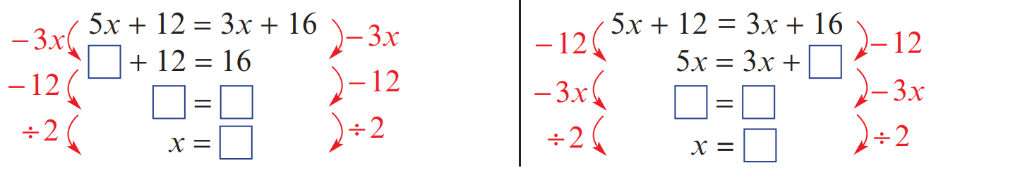  $$x=2$$ | $$x=2$$

The two equations above are the same. Which method do you prefer?

- Read the examples carefully and answer the questions.
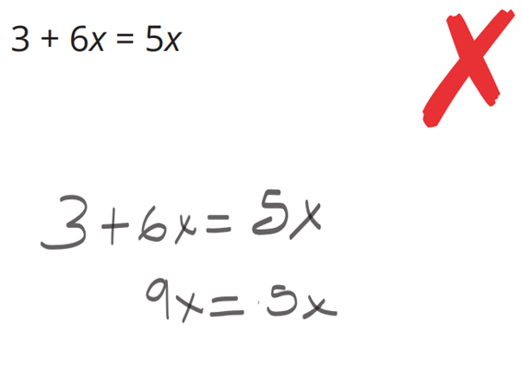  Jackson’s work: | Which terms did Jackson incorrectly combine to get $9x$?  $3+6x$. They are not like terms, so they can’t be combined.  Give an example of two terms that would correctly add to $9x$.  $$3x+6x$$  Solve:  $$-6x+3=-5x$$  $$x=-3$$
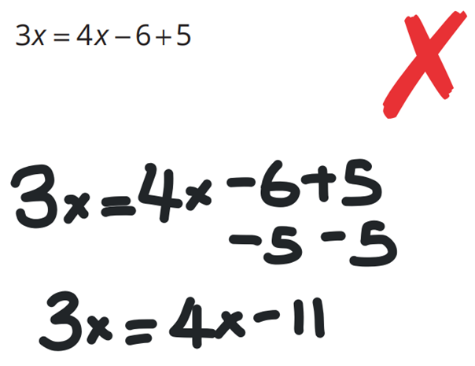  Umi’s work: | What did Umi do wrong in her first step?  Incorrect inverse operation.  Also, you need to subtract from both sides,  not from each constant term.  What should Umi have done on the right side of the equation to solve it?  Simplify – 6 + 5 to – 1, then subtract 3x or 4x from both sides.  Solve:  $$6x=3x-5-4$$  $$x=-3$$
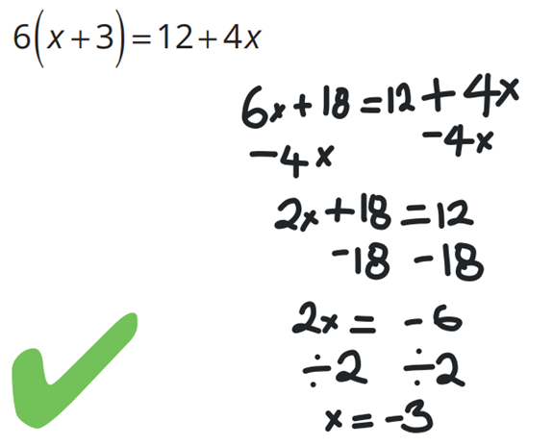  George’s work: | Where did George get $6x+18$ from?  He expanded the brackets  Solve:  $$-3\left(x+6\right)=4-5x$$  $$x=11$$

Mastery
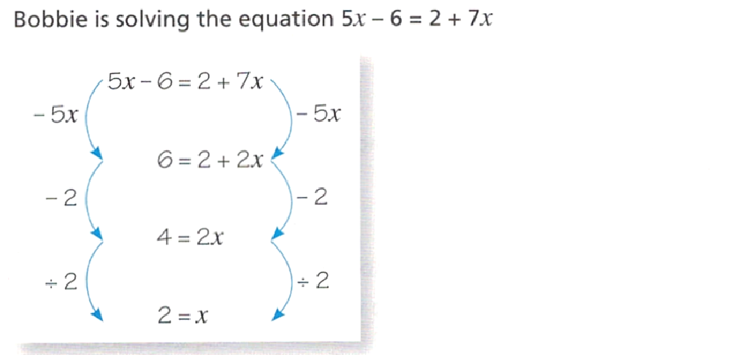

Verify Bobbie’s solution by substitution to show it is incorrect.
LHS $=$ | RHS $=$
LHS = 4 , RHS = 16
$LHS≠RHS$ so 2 is not the solution.
Identify Bobbie’s error and solve the equation correctly.

He should have kept the negative sign with 6 on the left.
$$x=-4$$
- Solve these equations. The answers may be positive or negative integers or fractions,
- $3m+7=8m+2$  $$m=1$$ | - $7t-6=4t+5$  $$t=\frac{11}{3}$$
- $6h-8=2h-7$  $$h=\frac{1}{4}$$ | - $12+3w=6w-4$  $$w=\frac{16}{3}$$
- $5p=2p+8$  $$p=\frac{8}{3}$$ | - $5p=2p-8$  $$p=-\frac{8}{3}$$
- $k-19=6k-3$  $$k=-\frac{16}{5}$$ | - $6t=4t+8-3t$  $$t=\frac{8}{5}$$

Further Problem-Solving using Equations

- Solving Problems using Equations
The problems in this section will involve pronumerals on both sides.
- Let a pronumeral, like $x$, represent the unknown quantity.
- Write an equation describing the scenario.
- Solve the equation.
- Check the answer makes sense and include units.

- Example Solve problems using equations with pronumerals on both sides.
Purchasing five apples and a $2.40 mango costs the same as purchasing seven apples and a mandarin that costs 60 cents. What is the cost of each apple?
1. Let $c=$ cost of an apple.
2. $5c+2.4=7c+0.6$
3. $2.4=2c+0.6$
$1.8=2c$
$0.9=c$
4. An apple costs 90 cents (or $\$0.90$)

- Guided Practice
- Purchasing 7 pencils and a $1 ruler is the same as purchasing 3 pencils and a $3.80 box of markers.  How much does a pencil cost?  1. Let …… be …………………………  2.  3.  4. | - Kathy’s age four years ago is the same as is half of her age now plus five.  Find Kathy’s age now.  1. Let …… be …………………………  2.  3.  4.

Foundation
- At a newsagency, Preeta bought four pens and a $1.50 newspaper, while her husband Levy bought two pens and a $4.90 magazine. To their surprise the cost was the same.
  - Write an equation to describe this, using $p$ for the cost of a pen.

$$4p+1.50=2p+4.90$$
  - Solve the equation to find the cost of a pen.

$$p=\$1.70$$
- Desmond notes that in 4 years’ time his age when doubled will give the number 50.
Desmond’s current age is $d$.
  - Write an expression for Desmond’s age in 4 years’ time and write an expression for double his age in 4 years’ time.

$$d+4, 2(d+4)$$
  - Write an equation to describe the situation described above.

$$2(d + 4) = 50$$
  - Solve the equation to find his current age.

$$d = 21 years$$

- Form an equation to solve the following.
  - Eight years ago, Tiff was half her age now. How old is Tiff now?

$$t-8=\frac{t}{2}$$
$$t=16$$
Tiff is 16.
  - Two years ago, Tiff's father was three times his own age 28 years ago.
How old is Tiffs father now?

$$f-2=3\left(f-28\right)$$
Father is 41

Development
- The following shapes are rectangles. By solving equations, find the value of the pronumerals.
Some of the answers will be fractions.
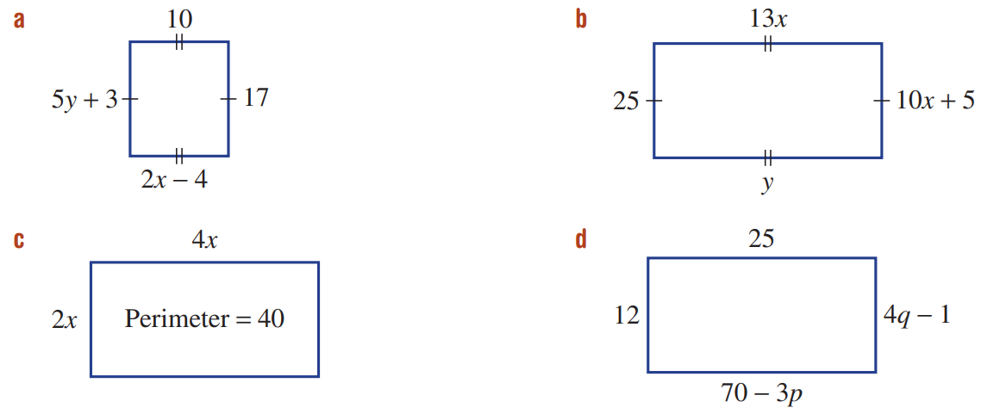  $$x=7, y=\frac{14}{5}$$ | $$x=2, y=26$$ | $$x=\frac{10}{3}$$
$$p=15, q=\frac{13}{4}$$ | 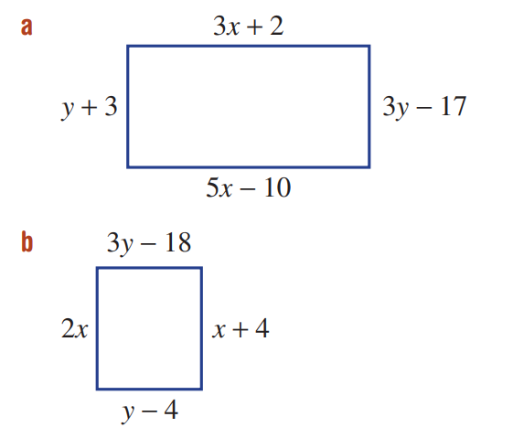  $$x=6, y=10$$ | $$x=4, y=7$$

- Find the values of the pronumerals in the following geometric diagrams.
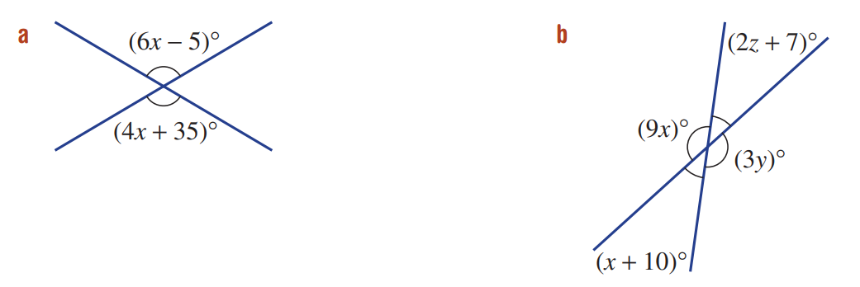  $$x=20$$ | $$x=17, y=51, z=10$$ | 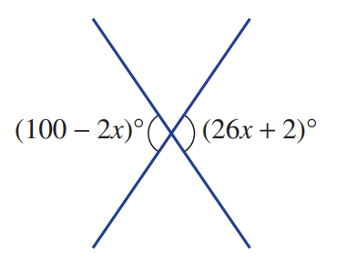  $$x=\frac{7}{2}$$

- I think of a number, double it and add 12. The answer is three times the number I started with. What was my starting number?
Let x = starting number
2x + 12 = 3x
12 = x
Starting number = 12
- I think of a number, double it and add 12. The answer is the number I started with.
What was my starting number?
Let x = starting number
2x + 12 = x
x = -12
Starting number = – 12
- I think of a number, add 12 and then double the result.
The answer is four times the number I started with.
What was my starting number?

Let x = starting number
2(x + 12) = 4x
x = 12
Starting number = 12
- Sally is 58 and Harry is 10 years old. In how many years will Sally be three times Harry’s age?

Let t = years from now
Sally's age in t years: 58 + t
Harry's age in t years: 10 + t
58 + t = 3(10 + t)
t = 14 years

- If you triple the age Rhys was four years ago, you get 27.
Form and solve an equation to find Rhys' age now.

Let x = Rhys' current age
3(x - 4) = 27
x = 13 years old

- If you double the age Ali will be in six years' time, you will get 40. How old is Ali now?

Let x = Ali's current age
2(x + 6) = 40
x = 14 years old
- Kate is three times as old as her son.
If Kate is also 30 years older than her son, what are their ages?
Let $x$ be son’s age
Kate’s age is $3s$ and $s+30$
$$30+x=3x$$
$$x=15$$
Son is 15, Kate is 45

Mastery
- Kristen and Daniel have the same amount of money.
Kristen buys 5 kg of cherries and has $2 left over.
Daniel buys 2 kg of cherries and has $20 left over. What is the cost of 1 kg of cherries?

Let $x$ be 1kg of cherries
$$5x+2=2x+20$$
$$x=6$$
1 kg is $6
- James and Sue have the same amount of money.
James buys seven sushi rolls and has $1.50 left over.
Sue buys four sushi rolls and has $12 left over. Find the cost of a sushi roll.

Let $x$ be 1 sushi
$$7x+1.5=4x+12$$
$$x=3.5$$
1 sushi is $3.50
- Find the unknown number using equations. The answers might not be whole numbers.
- The average of a number and double the number is 25.5.  $$\frac{x+2x}{2}=25.5$$  $$\frac{3x}{2}=25.5$$  $$3x=51$$  $$x=17$$ | - The average of a number and triple the number is 25.5.  $$\frac{x+3x}{2}=25.5$$  $$\frac{4x}{2}=25.5$$  $$2x=25.5$$  $$x=12.75$$
- Adding 3 to twice a number is the same as subtracting 9 from half the number.  $$2x+3=\frac{x}{2}-9$$  $$4x+6=x-18$$  $$3x=-24$$  $$x=-8$$ | - Adding 5 to twice a number is the same as subtracting 9 from half the number.  $$2x+5=\frac{x}{2}-9$$  $$4x+10=x-18$$  $$3x=-28$$  $$x=-\frac{28}{3}$$
- The average of a number and double the number gives the same result as adding 1 to the original number and then multiplying by one-third.
$$\frac{x+2x}{2}=\frac{1}{3}\left(x+1\right)$$
$$\frac{3x}{2}=\frac{x+1}{3}$$
$$9x=2(x+1)$$
$$9x=2x+2$$
$$7x=2$$
$$x=\frac{2}{7}$$
- Abdullah has 4 packets of mints and 7 more mints.
Beca has 2 packets of mints and 31 more mints.
Each packet contains the same number of mints.
If Abdullah and Beca each have the same number of mints, how many mints do they have altogether?
Let $x$ be number of mints in a packet.
4x + 7 = 2x + 31
x = 12
Together they have 6(12)+38=110
- Ed collects 5c and 10c coins in a jar. The jar contains three more 5c coins than 10c coins. Altogether there is $1.80 in the jar.
Form and solve an equation to find the number, $x$, of 10c coins in the jar.
Let x = number of 10c coins
Number of 5c coins = x + 3
5(x + 3) + 10x = 180
x = 11
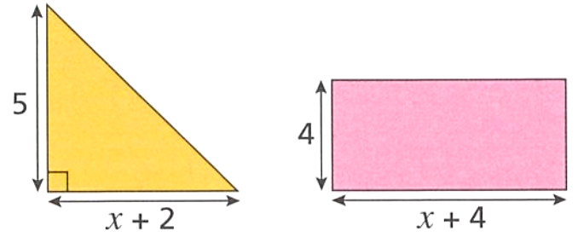
- The area of the rectangle is double the area of the triangle. Find both their areas.
Triangle area = $\left(\frac{1}{2}\right)\left(x + 2\right)\left(5\right)$= $\frac{5x + 10}{2}$
Rectangle area = $4(x + 4)$ = $4x + 16$
Rectangle area = 2 × Triangle area:
$$4x+16=2×\frac{5x+10}{2}$$
$$4x + 16 = 5x + 10$$
$$6 = x$$
Triangle area = 20
Rectangle area = 40
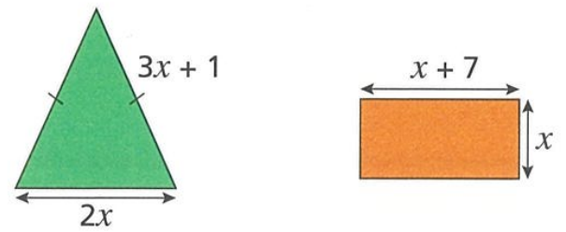
- The perimeter of the triangle is the same as the perimeter of the rectangle.
Work out the area of the rectangle.
Triangle perimeter = 2x + (3x + 1) + (3x + 1) = 8x + 2
Rectangle perimeter = 2(x + 7) + 2x = 4x + 14
Equal perimeters: 8x + 2 = 4x + 14
4x = 12
x = 3
Rectangle area = 3(3 + 7) = 30

- Find the area and the perimeter of this rectangle.
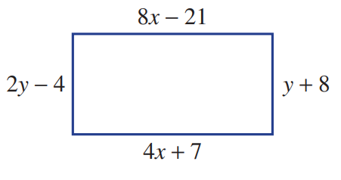
Opposite sides equal in rectangle:
8x - 21 = 4x + 7 and 2y - 4 = y + 8
x = 7,
y = 12
Length = 8(7) - 21 = 35
Width = 12 + 8 = 20
Area = 35 × 20 = 700
Perimeter = 2(35 + 20) = 110
- Show that the rectangular shape shown must be a square.
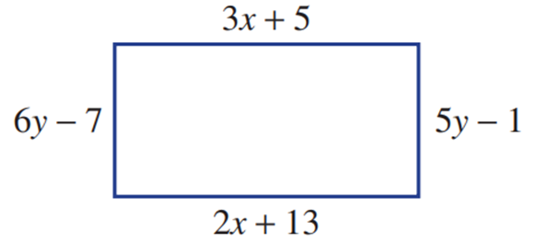
Opposite sides equal in rectangle:
3x + 5 = 2x + 13 and 6y - 7 = 5y - 1
x = 8 and y = 6
By substituting and evaluating each side, each side is 29.
A rectangle with all sides equal is a square.

- A man is currently three times as old as his son.
In 11 years from now he will be twice as old as his son will be then.
How old is his son now?
Let s = son's current age
Man's current age = 3s
In 11 years: (3s + 11) = 2(s + 11)
s = 11
Son is 11 years old now
- At present Jen is 8 years older than Wesley.
In 3 years from now, Jen’s age will be double Wesley’s age.
How old is Wesley?
Let w = Wesley's current age
Jen's current age = w + 8
In 3 years: (w + 8 + 3) = 2(w + 3)
5 = w
Wesley is 5 years old
- The sum of Kelly and Sam’s ages is 45 years.
If Kelly’s age was doubled, it would be 5 years more than three times Sam’s age.
How old is Sam?
Let s = Sam's age, k = Kelly's age
k + s = 45
2k = 3s + 5
use k = 45 - s
Substitute: 2(45 - s) = 3s + 5
s = 17
Sam is 17 years old
- Flo has two cats, Misty and Smokey. Misty is twice as old as Smokey.
In four years' time, the sum of their ages will be 17. How old is Misty now?
Let s = Smokey's current age, m = Misty's current age
m = 2s
(m + 4) + (s + 4) = 17
2s + s + 8 = 17
s = 3
m = 6
Misty is 6 years old

- Zach has two dogs, Autumn and Titch. Four years ago, Autumn was three times as old as Titch. The sum of their ages now is 12. What will be the sum of their ages next year?
Let a = Autumn's current age, t = Titch's current age
a + t = 12
(a - 4) = 3(t - 4)
Use a = 12 – t
12 – t – 4 = 3t – 12
t = 5, a = 7
Next year their ages will sum to 14

- Rectangles A and B have the same area.
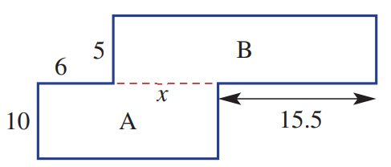
  - What is the value of $x$?

$$10\left(6+x\right)=5\left(15.5+x\right)$$
$$x=3.5$$

  - State the perimeter of the shape.
80

